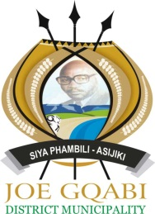

**JOE GQABI DISTRICT MUNICIPALITY WATER SERVICES DEVELOPMENT PLAN**

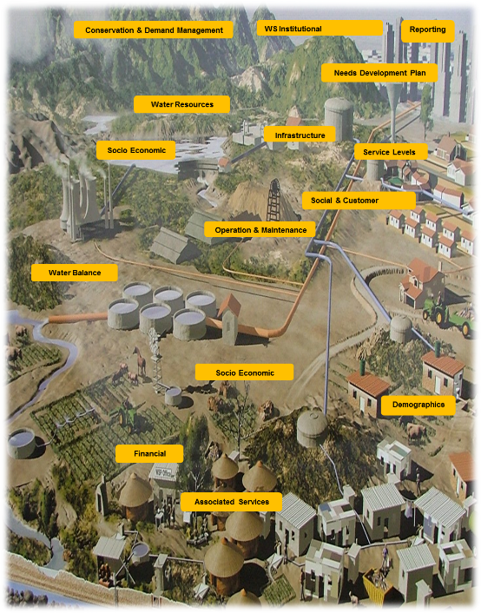

**OVERVIEW REPORT**

**REVISION 0**

**MARCH 2016**

ELEMENT CONSULTING ENGINEERS

East London Office

Tel: +27 43 726 0074

Fax: +27 43 726 0060

52 Stewart Drive, Baysville, East London, 5241

Po Box 19429, Tecoma, East London, 5214

www.eceng.co.za



|  |  |  |  |  |
| --- | --- | --- | --- | --- |
| **Document Control** | | | | |
| ***Project Number*** | | 150012 | | |
| ***Client Contract Number*** | | JGDM 2014/15 - 008 | | |
| ***Project Name*** | | Review of Joe Gqabi District Municipality Water Services Development Plan | | |
| ***Report Title*** | | Overview report 2016 | | |
| ***Authors*** | | D. Smith, P. Mantungwa | | |
| ***Status of Report*** | | Revision 1 | | |
| ***Date*** | | March 2016 | | |
| ***Previous Report(s)*** | | Draft Inception Report Revision 0 | | |
| ***Date(s)*** | | March 2015 | | |
| ***Previous Report(s)*** | | Joe Gqabi WSDP Overview Report | | |
| ***Date(s)*** | | June 2015 | | |
| ***Previous Report(s)*** | | IDP Insert | | |
| ***Date(s)*** | | May 2015 | | |
| ***Previous Report(s)*** | | Draft Inception Report 2016 Revision 0 | | |
| ***Date(s)*** | | November 2015 | | |
| Approved for Element Consulting Engineers by: | | | | |
| Dennis Smith  Project Director | Date | | Quinten Cloete  Project Engineer | Date |
| Approved for Joe Gqabi District Municipality by: | | | | |
| Ms. F. Sephton Date  Director: Community Services | | | Mr H. Christians Date  Project Manager | |
| http://www.joegqabi.gov.za/images/stories/Logos/logo%20layout%20%20height%2025.jpg**Prepared for:** | | | Description: logosml **Prepared by:** | |
| Joe Gqabi District Municipality  Private Bag X102  Barkly East  9786  Tel: +27 45 979 3000  Fax: +27 45 971 0251  Contact:  Mr H Christians  [hendry@jgdm.gov.za](mailto:hendry@jgdm.gov.za) | | | Element Consulting Engineers  PO Box 19429  TECOMA, EAST LONDON  5241  Tel: +27 43 726 0074  Fax: +27 43 726 0600  Contact:  Mr P. Mantungwa  [pmantungwa@eceng.co.za](mailto:pmantungwa@eceng.co.za) | |

**Table of Contents**

1 Introduction and Background 1

2 The Water Services Imperative 3

2.1 WSA Legal Accountability 3

2.2 Water Services Supply Groups 4

3 The Water Services Development Plan 5

3.1 Legal Frameworks 5

3.2 WSDP Planning Process 6

3.3 Preparation Team 8

4 Physical Overview of the Joe Gqabi District Municipality 9

5 Level of Service and Theoretical Services Demand 13

5.1 Level of Service 13

5.2 Bylaws 13

5.3 Basic Services Definition 13

5.4 The Water Ladder Concept 14

5.5 Unit Demands 14

6 Economic Perspectives 16

7 Demographics and Socio Economic Considerations 17

7.1 Migration 20

7.2 Population Growth 21

8 Backlogs 22

8.1 Water Backlogs 22

8.2 Sanitation Backlogs 24

9 Strategies to Eradicate Backlogs 27

9.1 Water 27

9.2 Sanitation 27

10 Water Services Resources 30

10.1 Surface Water Resources 30

10.1.1 JG Water Resources 31

10.2 Status of Surface Water Resources 33

10.2.1 Gariep LM 33

10.2.2 Maletswai LM 33

10.2.3 Senqu LM 33

10.2.4 Elundini LM 34

10.3 Subterranean Water 35

10.4 Possible long term water supplies 36

10.4.1 Mzimvubu River Water Resources Development 36

10.4.2 Orange River 36

10.5 Water Balance 37

10.6 Environmental Water Quality 37

11 Wastewater Facilities 38

12 Financial Profile 42

12.1 Operating Budget 42

12.2 Other Key Budget Components 44

12.3 Capital Budget 45

12.4 Sources of Capital 45

12.5 Water Services Backlog Eradication Possible Timelines 47

12.6 Budget Reforms 51

13 Status of Water Services Infrastructure 53

13.1 Visual Inspection of Water Treatment Facilities 53

13.1.1 Elundini LM WTW 53

13.1.2 Senqu LM WTW 54

13.1.3 Maletswai LM WTW 55

13.1.4 Gariep WTW 55

13.1.5 General Perspectives of JGDM WTW 55

13.2 Visual Inspection of Wastewater Treatment Facilities 56

13.2.1 Elundini WWTW 56

13.2.2 Senqu WWTW 57

13.2.3 Maletswai WWTW 58

13.2.4 Gariep WWTW 58

14 Infrastructure Requirements 62

14.1 Existing Initiatives 62

14.2 Overall Master Planning 63

14.2.1 Senqu Plans 63

14.2.2 Recent Initiatives in Senqu 63

14.2.3 Elundini Plans 63

14.2.4 Maletswai Plans 64

14.2.5 Gariep Plans 64

14.3 Technical Reports 65

15 Water Conservation and Demand Management 66

15.1 Demand-side Management 69

15.2 Supply-side Management 70

16 Priority Intervention Action Plan 71

17 Water Service Institutional Profile 73

17.1 The Macro/External Environment 73

17.2 The Micro/Internal Environment 74

17.3 Current Structure 75

18 Conclusions 76

18.1 Employee and Leadership Development 77

18.2 Operational Optimisation 77

18.3 Financial Viability 77

18.4 Infrastructure Stability 77

18.5 Operational Resiliency 77

18.6 Community Sustainability 78

18.7 Water Resource Adequacy 78

18.8 Stakeholder Understanding and Support 78

18.9 Product Quality 78

18.10 Customer Satisfaction 78

**Table of Tables**

Table 4‑1: Table of Physical Information on JGDM 11

Table 7‑1: Households and Household Distribution 17

Table 7‑2: Unemployment Statistics from Census 2011 20

Table 8‑1: Water Backlogs in Elundini 22

Table 8‑2: Water Backlogs in Senqu LM 22

Table 8‑3: Water Backlogs in Maletswai LM 23

Table 8‑4: Water Backlogs in Gariep LM 23

Table 8‑5: Water Backlogs in the JGDM area, consolidated 23

Table 8‑6: Sanitation Backlogs in Elundini LM 24

Table 8‑7: Sanitation Backlogs in Senqu LM 24

Table 8‑8: Sanitation Backlogs in Maletswai LM 25

Table 8‑9: Sanitation Backlogs in Gariep LM 25

Table 8‑10: Sanitation Backlogs in the JGDM Area Consolidated 25

Table 10‑1: JGDM Surface Water Resources 32

Table 10‑2: JGDM Groundwater Resources 35

Table 12‑1: Capital Grants for the JGDM according to the 2016 DORA Bill 46

Table 12‑2: COGTA SDIP Capital Budget for JGDM as per IPP 46

Table 12‑3: JGDM Infrastructure Implementation Plan Water Services Planned Investments 47

Table 15‑1: National Water Conservation/Water Demand Strategy Framework Objectives 67

Table 15‑2: First Outcomes of JGDM Water Balance 68

**Table of Figures**

Figure 1‑1: Joe Gqabi Locality in the Eastern Cape Province 1

Figure 1‑2: Joe Gqabi DM with Local Municipalities 2

Figure 3‑1: Inputs into the WSDP Process 6

Figure 4‑1: Joe Gqabi Topography 9

Figure 4‑2: Joe Gqabi Rainfall and Evaporation 10

Figure 4‑3: Daily Temperature variation in JGDM 10

Figure 4‑4: Average monthly rainfall and raindays 12

Figure 6‑1: Economic Sectors in JGDM 16

Figure 7‑1: Racial Profile 17

Figure 7‑2: Income Profile 18

Figure 7‑3: JGDM Dependency Ratio 19

Figure 7‑4: JGDM Gender profile 19

Figure 7‑5: Age and Gender Pyramid for JGDM 20

Figure 9‑1: The Earth Auger System 28

Figure 12‑1: JGDM Income vs Expenditure 43

Figure 12‑2: JGDM Budget Structure for Water Supply Services 44

Figure 12‑3: JGDM Budget Structure for Sanitation Services 45

Figure 12‑4: Backlog Eradication against annual MIG Requirement 47

Figure 12‑5: Outstanding Backlogs against Capital Requirement over time 48

Figure 12‑6: MIG Allocations at 72% against the Backlog Burden over time 49

Figure 12‑7: Backlog Eradication need against Capital Requirements over time 50

Figure 12‑8: Recent (2016) Backlog Eradication Scenarios 50

Figure 12‑9: Comparison Between MIG MTEF allocations over two budget cycles 51

Figure 15‑1: JGDM Water Revenue and Billing Profile per LM 69

Figure 15‑2: Ugie WTW Capacity vs Demand and Reserve Margin of 15% 69

Figure 15‑3: Ugie WTW Capacity vs Demand and Reserve Margin of 15% 70

Figure 17‑1: South Africa's Water Management Structure and Relationships 73

Figure 18‑1: Effective Utility Management Factors 76

**ANNEXURES**

ANNEXURE A: Project Implementation Plan

ANNEXURE B: Elundini Water Treatment Works

ANNEXURE C: Senqu Water Treatment Works

ANNEXURE D: Gariep Water Treatment Works

ANNEXURE E: Maletswai Water Treatment Works

ANNEXURE F: Elundini Wastewater Treatment Works

ANNEXURE G: Senqu Wastewater Treatment Works

ANNEXURE H: Gariep Wastewater Treatment Works

ANNEXURE I: Maletswai Wastewater Treatment Works

ANNEXURE J: Photo Gallery of the Water and Wastewater Treatment Works

ANNEXURE K: Mzimvubu River Water Resources Development information

ANNEXURE L: Orange River information

# Introduction and Background

The Joe Gqabi District Municipality (DC 14) came into existence due to the Municipal Structures Act (act 117 of 1998, Structures Act) in December 2000 following Municipal Elections. The borders and composition of the municipality were determined by the Municipal Demarcation Board. This body is tasked with the determination of local government borders and internal ward arrangements. The municipality was previously known as the Ukhahlamba District Municipality, but was later renamed in honour of Joe Nzingo Gqabi, a struggle stalwart who was born in Aliwal North and died in exile.

The Joe Gqabi District Municipality (JGDM) is a Water Services Authority (WSA) for its area of jurisdiction in terms of the Water Services Act (act 108 of 1997, WS Act). It therefore has statutory responsibilities and accountability in terms of legislation and policy with respect to the provision of water services.

Figure ‑: Joe Gqabi Locality in the Eastern Cape Province

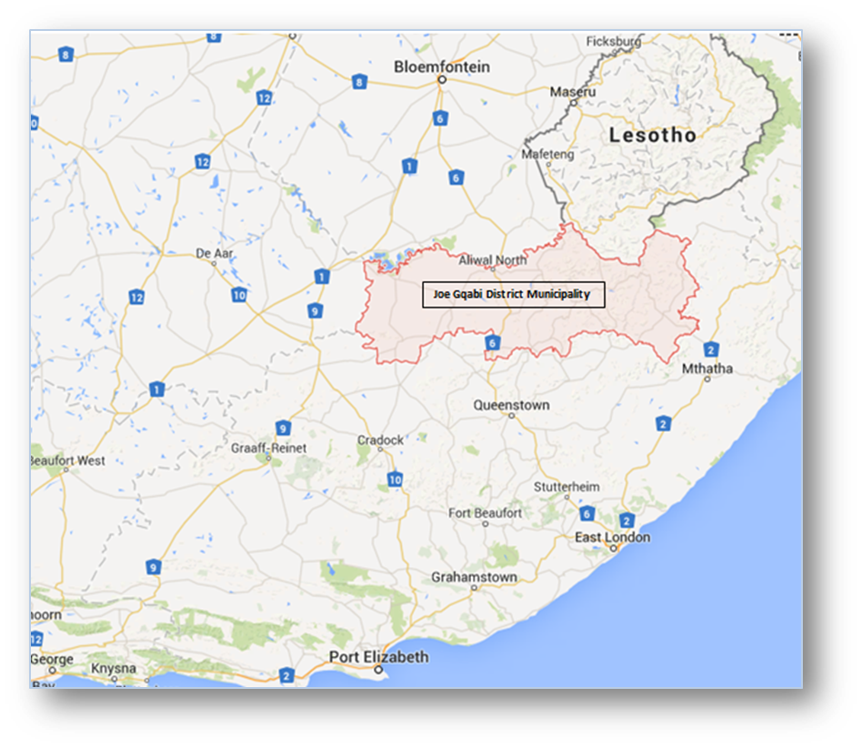

The JGDM is situated along the northern border of the Eastern Cape Province. The municipality is made up of four local municipalities, namely Gariep, Maletswai, Senqu and Elundini. The N6 national highway runs near the centre of the municipality in a north/south direction. Other major routes that serve the municipality are the R56 in a general east/west direction and the R58 in a general north-east/south-west direction. These roads also connect the main towns in the JGDM. There are main towns in each local municipality area, namely:

* Gariep Local Municipality (Oviston, Steynsburg, Venterstad, Burgersdorp)
* Maletswai Local Municipality (Aliwal North, Jamestown)
* Senqu Local Municipality (Sterkspruit, Barkly East, Rossouw, Rhodes, Lady Grey
* Elundini Local Municipality (Ugie, Maclear, Mount Fletcher

The administrative centre of the JGDM is located in Barkly East.

Figure ‑: Joe Gqabi DM with Local Municipalities

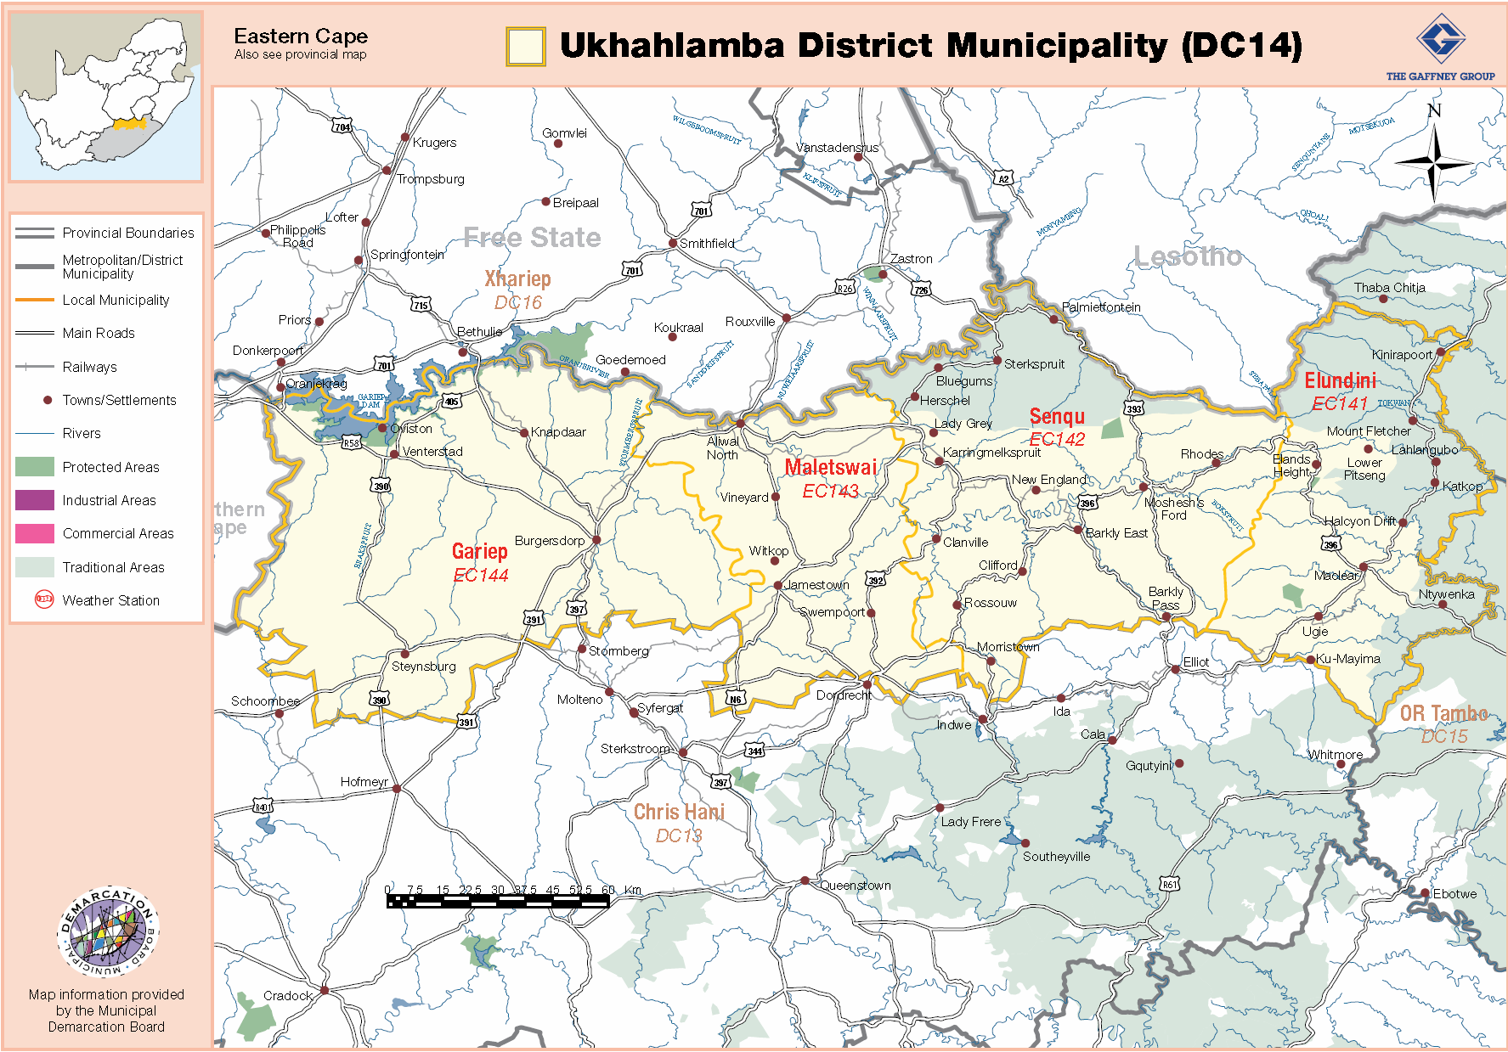

The Demarcation Board has announced the merger of the Gariep and Maletswai Local municipalities into a single entity by the 2016 Local Government elections. The date for these elections has been set for 3 August 2016. The impact on Water and Sanitation should be minimal, as the provision and regulation of the services falls within the JGDM and operational centres will in all likelihood be the same for the operational functions. Travel distances to a local administrative centre may be impacted on as management may be rationalised and other services may also be rationalised. The final outcome of the merger is not fully known at this stage.

# The Water Services Imperative

The slogan that underpins the provision of water services reads as follows:

***Water is Life,***

***Sanitation is Dignity***

These two components of water services are cornerstones of human civilization and humanness, and have been afforded critical importance and status in the compact of the South African state with its citizens. Policy and legislation has been formulated to guide and regulate the provision of these services and local Government has been entrusted in the Constitution of the Republic of South Africa for the provision of these services with the support of National and Provincial Government.

## WSA Legal Accountability

The statutory accountability covers the following roles and responsibilities for the area of water and sanitation or Water Services:

**Ensure Access** - *JGDM must ensure the realisation of the right to access to water services, particularly basic water services (the first step up the ladder) subject to available resources by seeing that appropriate investments in water services infrastructure are made*

**Planning** - *JGDM must prepare water services development plans to ensure effective, efficient, affordable, economical and sustainable access to water services which promote sustainable livelihoods and economic development (stepping up the ladder)*

**Regulation** - *JGDM must regulate water services provision and water services providers within their area of jurisdictions and within the policy and regulatory frameworks set by DWS through the enactment of by-laws and the regulation of contracts*

**Provision** - *JGDM must ensure the provision of effective, efficient and sustainable water services (including water conservation and demand management) either by providing water services themselves or by selecting, procuring and contracting with external water services providers. The provision of water services also includes communication activities related to, amongst other things, gender-sensitive hygiene promotion and the wise use of water*

The majority of South Africans have been denied access to these services. The government has therefore prioritised to normalisation and rectification of this situation with the enactment of legislation and the provision of financial support and targets for the eradication of basic services backlogs. Institutions have been reformed to support the government’s obligation and initiatives for universal access to water and sanitation services at a basic level. This obligation is articulated in the Strategic Framework for Water Services as follows:

***Universal service obligation***. *Water services authorities have a responsibility to ensure that all people living within their jurisdiction are progressively provided with at least basic water services (the first step up the ladder). This includes people living on private land (for example, farm dwellers) and others who are provided services by intermediaries. Wherever practical and sustainable, water services authorities are expected to plan for and provide higher levels of service (stepping up the ladder).*

## Water Services Supply Groups

The JGDM has a number of groups that require water services over a range of settings from rural to urban. The municipality is largely rural. There are other important customer categories that require water services, but the WSA’s accountability is the same for all. There is however a need for the WSA to ensure that communities within it are integrated and sustainable. Therefore, community services and businesses are important to ensure the sustainability of human settlements and improve the ability of people to pay for services. The WSA can also diversify its income base by supporting consumer types other than households.

# The Water Services Development Plan

The Water Services Development Plan (WSDP) is a statutory plan and fits into the overall planning framework that is governed by the Integrated Development Plan (IDP). The WSDP is the primary planning instrument for the Water Services sector of a municipality. The plan must take, as a minimum, cognisance of the *physical, social, economic, financial, environmental and institutional* aspects of water services provision in a particular water services authority area. The planning format has largely been driven by the Department of Water and Sanitation (DWS) and the 3 modules framework is now taken as adequate for the purposes of compliance by DWS.

The WSDP is but one of several planning documents that local government is legally compelled to compile, implement and maintain. The relative positions of various plans are depicted in the schematic below.

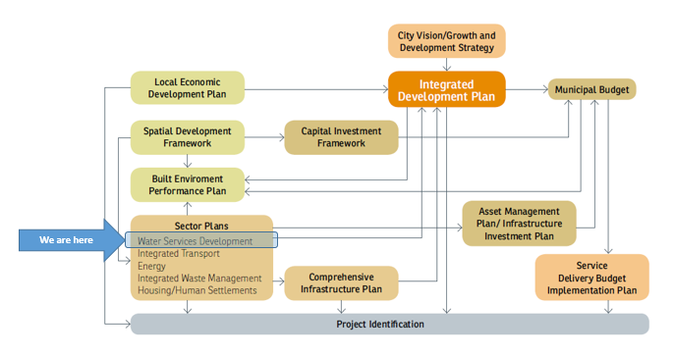

## Legal Frameworks

The need to provide water and sanitation services to the population of South Africa is founded in the Constitution of South Africa. The following legislation directly guides the provision of water services

* The Constitution of the RSA, 1996 ( Act 108 of 1996)
* The White Paper on Local Government (1998)
* The Local Government: Municipal Systems Act, 2000 ( Act 32 of 2000)
* Municipal Planning and Performance Management Regulations 2001(No 796, 24 August 2001)
* Regulations for Municipal Managers and Managers reporting directly to Municipal Managers, 1 August 2006
* The Local Government : Municipal Structures Act, 1998 (Act 117 of 1998)
* The Local Government: Municipal Financial Management Act , 2003 (Act 66 of 2003)
* The Batho Pele White Paper (1998)
* Infrastructure Development Act (Act 23 of 2014)

The following policies and strategies guide the provision of water services

* Water Services Act (WSA)
* The National Water Act (NWA)
* The Strategic Framework for Water Services (SFfWS)
* National Water Resources Strategy (NWRS)

There are various regulations under the acts that spell out some detail with respect to service provision and standards, e.g. the

* Guidelines for Compulsory National Standards (regulations under section 9 of the WSA, act 108 of 1997)
* Norms and Standards for Water Services Tariffs (regulations under section 10 of the WSA, act 108 of 1997))

It must be noted that the DWS is looking at reviewing water legislation and the policy framework is being revised and consolidated.

## WSDP Planning Process

The WSDP planning process should run concurrently with the IDP planning process as the IDP is the apex plan, while the WSDP is a sector plan of the IDP.

Figure ‑: Inputs into the WSDP Process

In turn, the WSDP relies on a number of plans for its compilation. This process should be iterative until all plans are fine-tuned and in harmony.

## Other imperatives

### Division of Revenue

The 2016 MTEF DORA is based on achieving the following objectives:

* Introducing appropriate incentives to upgrade and maintain provincial and municipal infrastructure.
* Extending HIV/AIDS intervention spending to include tuberculosis.
* Completing the eradication of bucket sanitation systems in formal residential areas.
* Extending access to early childhood development centres through a new grant.

Maintenance and upgrading of existing infrastructure must therefore be taken into account in planning over the next three years.

### The Medium-Term Strategic Framework (2014 – 2016)

The MTSF is the current government’s compact with respect to goals that must be achieved over the current electoral term until 2019. In terms of water and sanitation, the following outcomes must be noted and taken into account in the JGDM planning and its own delivery targets. The MTSF sets out 14 outcomes that must be met by 2019, 4 of which impact directly on water and sanitation and the funding sources designed to achieve the outcomes, namely:

Figure ‑: MTSF Outcomes impacting on Water and Sanitation

The bucket eradication programme is in its final year and may or may not be extended as provision has been made only for the completion of currently incomplete projects. JGDM still has bucket and these may have to be eradicated under the other capital grant programmes.

## Preparation Team

The WSDP is a Joe Gqabi document, but a service provider has been appointed to assist and capacitate the DM in the preparation process. The following team has been involved in the compilation of the WSDP.

Table ‑: JGDM 2016/17 WSDP Review Team

|  |  |  |
| --- | --- | --- |
| **Name** | **Designation** | **Organisation** |
| **Fiona Sephton** | Director: Community Services | JGDM: Community Services |
| **Robert Fortuin** | Director Technical Services | JGDM: Engineering |
| **Hendry Christians** | WSA Manager | JGDM: Water Services Authority |
| **Dumisani Lusawana** | WSP Manager | JGDM: Water Services Provider |
| **Thembelani Ngceba** | Water Manager Rural | JGDM: Elundini LM |
| **George Qwazi** | Water Manager Towns | JGDM: Elundini LM |
| **Peter Mathebula** | Water Manager | JGDM: Maletswai LM |
| **Vusi Ndaki** | Water Manager | JGDM: Sterkspruit LM |
| **Riaan Potgieter** | Acting Water Manager | JGDM: Gariep LM |
| **Karel McCarthy** | Acting Water Manager | JGDM: Senqu LM |
| **Lusanda Ndikisa** | Plant Controller | JGDM: Ugie (Water and Sanitation) |
| **Sibongile Mnengisa** | Plant Controller | JGDM: Mount Fletcher (Water and Sanitation) |
| **Malefu Saule** | Manager | JGDM: Municipal Health Services |
| **Stompie Louwrens** | EHP Coordinator Water Quality | JGDM: Water Quality |
| **Dennis Smith** | Project Director | Element Consulting Engineers |
| **Phiko Mantungwa** | Project Manager | Element Consulting Engineers |
| **Jarryd van Dyk** | Trainee Technician | Element Consulting Engineers |

# Physical Overview of the Joe Gqabi District Municipality

The JGDM is situated in the northernmost portion of the Eastern Cape Province. A large part of the eastern portion of the DM lies in the foothills of the Drakensberg mountain range. The terrain is therefore mountainous in these regions. The map hereunder illustrates the general topography.

Figure ‑: Joe Gqabi Topography

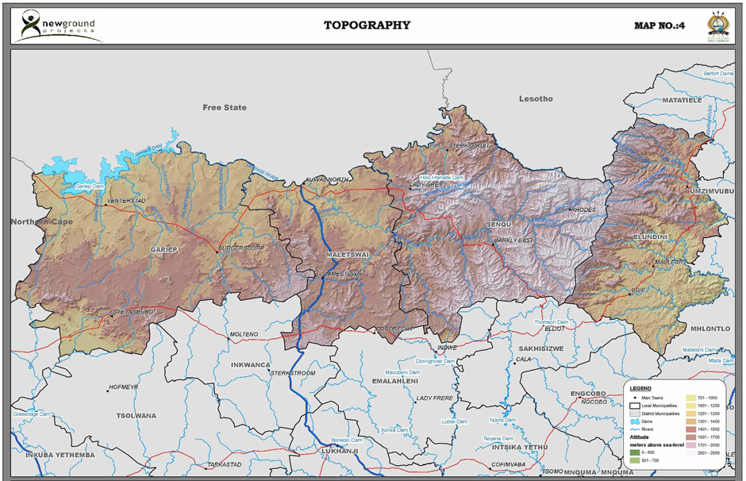

The western portion has a more gently sloping landscape with mostly large flat plains. The area of the JGDM falls mainly in the Gariep River drainage to the west and central areas and the T-drainage system to the easternmost parts. The water management areas are designated as WMA 13 (Upper Orange WMA) in the west and WMA 12 (Umzimvubu to Keiskamma) in the far-east. The Kraai River is a main drainage basin in the area and forms part of the Orange River system, flowing in a westerly direction, with tributaries flowing mainly in a northerly or southerly direction.

Rainfall in the JGDM area ranges from lower rainfalls in the west to higher rainfall in the east. The area receives mainly summer rains, with some, yet limited rains in the winter mains due to the effects of temperate cyclones (fronts). There are three bands of rainfall with the western most areas receiving between 400 and 600 mm per annum, the central band receiving between 600 and 800 mm per annum, with the eastern band receiving between 800 and 1 000 mm per annum, with some small pockets receiving in excess of 1 000 mm per annum[1] in the eastern parts. Some areas in the extreme west receive less that 400mm per annum.

Figure ‑: Joe Gqabi Rainfall and Evaporation

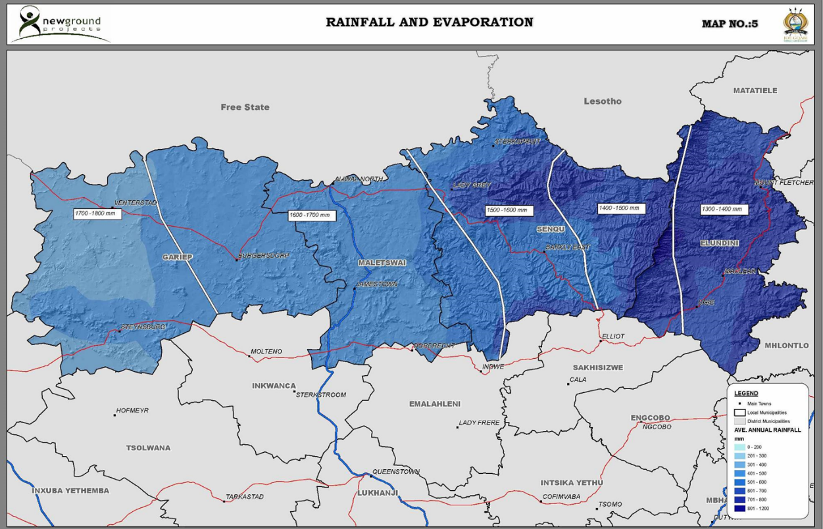

The topographical features of the area are summarised in the table below, extracted from the 2010/11 WSDP.

Summer temperatures average between 20⁰C and 22.5⁰C, while average daily temperatures in winter are below 7.5⁰C.

Figure ‑: Daily Temperature variation in JGDM[2]

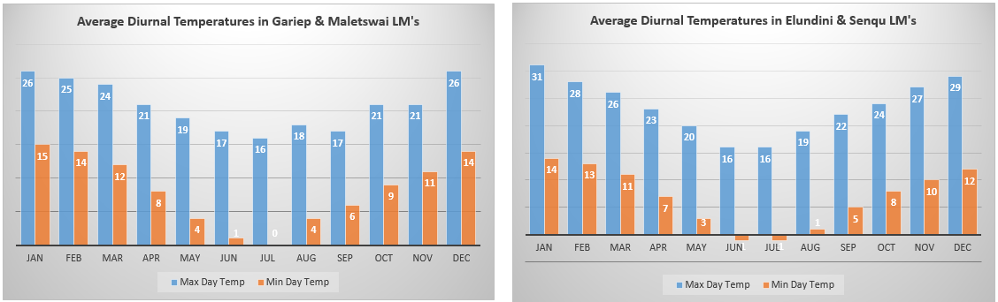

The vegetation in the JGDM area is mostly grassland in the central and eastern areas. The vegetation in the westernmost regions is predominantly Nama-Karoo.

The topographical and climatic conditions of the area, combined with some population characteristics are summarised in the table below, extracted from the 2010 WSDP.

Table ‑: Table of Physical Information on JGDM

|  |  |  |  |  |  |  |
| --- | --- | --- | --- | --- | --- | --- |
| **LM** | **Topography** | **Rainfall** | **Population density** | **Commercial farms vs communal land** | **Urban vs rural character** | **Accessibility** |
| Elundini | Mountainous area especially in the Western and Northern parts of the LM. Peaks reach a height of 3 000 m above sea level. | The area receives the highest rainfall figures of between 800 mm and 1 000 mm per year.  Evaporation is between 1 300 mm and 1 500 mm per year. | This area has relatively high population densities. | The area is characterised by large areas of communal land where dense communities are located. | The majority of people reside in the rural areas in tribal villages and traditional homes. | The high mountains make accessibility to the area difficult.  Few roads give access to the area. |
| Senqu | The area is mountainous especially in the East. | The area receives between 400 mm and 800 mm rainfall per year.  Evaporation is between 1 400 mm and 1 700 mm per year with the Western portions having higher evaporation. | The area has a relatively high population density. | The area is characterised by communal areas. Dense communities are located in the North of the LM. | The majority of people reside in the rural areas in tribal villages and traditional homes. | The high mountains make accessibility to the area difficult. Few roads give access to the area especially in the East. |
| Maletswai | Flat in the Northern part and a mountainous/ rolling (small hills) area South. | The area receives between 400 mm and 600 mm rainfall per year.  Evaporation is between 1 500 mm and 1 800 mm per year with the higher figure in the West. | The area has a relatively low population density | The area is characterised by commercial farming. | The majority of the population reside in urban areas and mostly live in formal dwellings. | The area is more accessible than the Eastern areas. A number of roads give access to the area. |
| Gariep | Largely flat with a rolling topography in the South. | The area receives between 200 and 600 mm per year.  Evaporation is between 1 600 mm and 1 800 mm per year. | The area has a low population density | The area is characterised by commercial farms. | The majority of the population reside in urban areas and mostly live in formal dwellings. | The area is relatively easily accessible. More roads give access to the Eastern part. |

Recent rainfall in the two regions of the JGDM is depicted in the graphics below. This includes the average number of rain days per month.

Figure ‑: Average monthly rainfall and raindays[3]

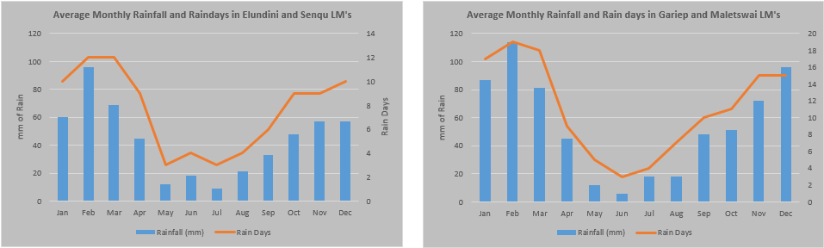

The eastern portion recorded average rainfall of 648mm between 2000 and 2012, while the western portion recorded an average of 525mm. Rainfall is variable and some places in the east can receive over 1000mm of rain. The rea in general has been experiencing drought conditions of late.

# Level of Service and Theoretical Services Demand

The provision of water and sanitation has qualitative and quantitative dimensions that are circumscribed. Core guidelines are set down by the Department of Human Settlements in the *Guidelines for Human Settlement Planning and Design* (so-called “Red Book”). Local Government has the prerogative to modify and improve these guidelines and standards to suite local conditions. The JGDM has not developed or customised its own design and construction standards. The Red Book standards and guidelines are therefore followed in the main, unless qualified.

## Level of Service

The provision of water and sanitation is guided by National policy and legislation. Policy and legislation requires that all households be provided with a basic Level of Service (LOS). The definition of service levels was influenced by the Reconstruction and Development Plan (RDP) to comprise a water supply standpipe with a maximum walking distance per household of 200m, and a Ventilated Improved Pit latrine. This standard has endured, but has been modified by an aspirational goal set in the Strategic Framework for Water Services (SFWS).

There are also principles of equitability that must be taken into consideration, namely ensuring that service levels are not unfair with respect to households in the same situation. WSA’s are therefore permitted to apply higher levels of service commensurate with abilities to pay, but in the context of consistency within communities and across communities.

All WSA’s are therefore required to either develop or use a generic Level of Service Policy, coupled with polices for tariffs, payment and indigence to support the LOS decided on to ensure that there is equity and sustainability.

## Bylaws

It is also advisable that all WSA’s devise bylaws to govern the provision of services and to give effect to policy. The JGDM has devised a set of bylaws to regulate the provision of services including water and sanitation. The bylaws are well compiled and adequate.

## Basic Services Definition

The concept of Basic Services has been defined to ensure consistency in compliance with the objectives of policy and legislation and the expectations of people. These definitions were set in the SFWS in 2003.

***Basic Water Supply Service:*** The provision of a basic water supply facility, the sustainable operation of the facility (available for at least 350 days per year and not interrupted for more than 48 consecutive hours per incident) and the communication of good water-use, hygiene and related practices.

***Basic Sanitation Supply Service:*** The provision of a basic sanitation facility which is easily accessible to a household, the sustainable operation of the facility, including the safe removal of human waste and wastewater from the premises where this is appropriate and necessary, and the communication of good sanitation, hygiene and related practices.

Both definitions are comprehensive to ensure adequacy of services. The SFWS also continues to expand the concept of basic services by the following explanation, quoted verbatim:

***“Basic services*** *(the first step). As a priority, it is the responsibility of the water services authority to make sure that adequate and appropriate investments are made to ensure the progressive realisation of the right of all people in its area of jurisdiction to receive at least a basic level of water and sanitation services. The grants provided by national government in the form of the municipal infrastructure grant (MIG) will be adequate to ensure universal provision of at least a basic water supply facility and a basic sanitation facility within a reasonable period of time. This is called a universal service obligation and is the most important policy priority*.”

The provision of basic services has to be prioritised and the eradication of backlogs must therefore be a first priority of services provision. The *“reasonable”* period of time needs to be firmed up by the WSA.

## The Water Ladder Concept

The SFWS proposes the concept of the *“water ladder”*, an aspirational approach that seeks to improve service levels in the context of affordability and sustainability for each WSA. It is expected that National Government will continue to provide grants to improve service levels beyond the basic levels once these are attained. This principle has significant implications to the strategies of service provision and planning in the form of horizons, service levels and design standards must take into account that service levels may have to have an element of flexibility such that sunk costs are avoided.

The Medium Term Strategic Framework (MTSF) of government expects 90% of households to have basic services by 2019 while the National Development Plan (NDP) expects backlogs to be eradicated by 2030.

## Unit Demands

Common practice is to allocate a theoretical household consumption of 1 000ℓ/hh/day for urban areas. RDP standards suggest a demand of 25ℓ/c/d. The RBIG design guidelines call for an allocation of 60ℓ/c/d. In the early stages of the RDP standards, it was common practice to accept 5 to 6 occupants per household. Household sized has been in decline in most areas of the country. This may be due to various factors, including migration (seasonal or permanent) fracturing of family units etc. It is now common to design for 4 to 4.5 occupants per household. It is also common for the household demand to average around 850ℓ/hh/day. Water and sanitation services are demanded and delivered to households. In the analyses, the household is taken as the demand unit and per capita information is used in conjunction with occupancy assumptions to derive a household demand. All unit demand assumptions must include an allowance of 15% for water losses. Waterborne Sanitation flows can be assumed to be 75% of the household water demand.

All theoretical demand and provision calculations are based on these unit service levels.

# Economic Perspectives

The JGDM area had a Gross Value Add (GVA) of R6 457 million at current prices in 2010. This comprised 3.57% of the Eastern Cape GVA and 0.27% of the South African economy. The area however has 5.3% of the provincial population. This implies that the area punches below its weight compared to its population contribution.

The economy of the JGDM area is dominated by the tertiary sector, which comprises 80% of the district economy. The tertiary sector in turn is dominated by the government and community services. Agricultural, and specifically animal husbandry is the mainstay of the primary economy. It stands to reason then that the area will have a high grant dependency to augment its per capita income deficit compared to the province and the country.

Figure ‑: Economic Sectors in JGDM

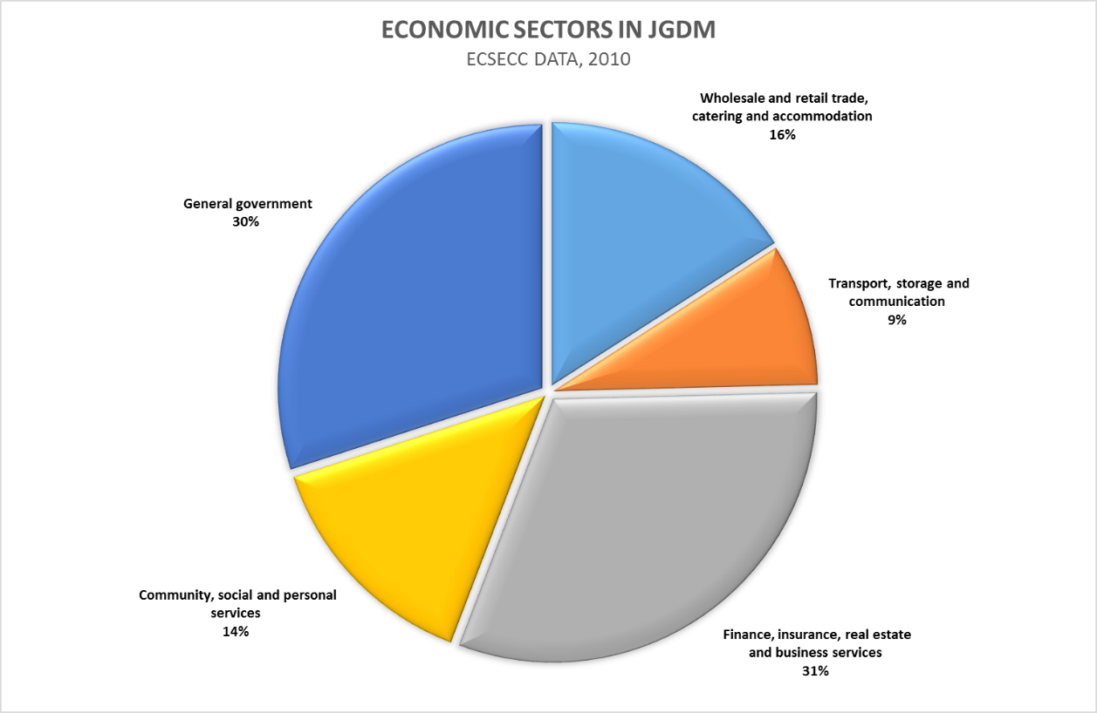

The structure of the JGDM economy has implications for the capabilities of the population and households in the area. The district municipality has established an economic development agency to guide the development of the local economy.

# Demographics and Socio Economic Considerations

The demographics of the JGDM for the compilation of the WSDP has been extracted from the Statssa Census 2011 dataset. Normally, the IDP process sets the base information that is utilised by all planning documents such that a single reference set of data is used and consistency is ensured. At the initiation of the 2015/16 WSDP, discussions were held with Mr T. Mpitshane of the IDP office to obtain demographic data. At that stage, it was recommended that the WSDP process proceeds with the Census 2011 data until the IDP process finalizes a municipal demographic data set, possible for the 2016/17 planning cycle. All references to demographic data used and quoted hereunder must be viewed against this backdrop.

Joe Gqabi DM has a population of 349 768 persons, with 98 748 households.

Table ‑: Households and Household Distribution

|  |  |  |
| --- | --- | --- |
| **Local Municipality** | **Number of Households** | **Distribution** |
| EC141: Elundini | 37 854 | 38,7% |
| EC142: Senqu | 38 046 | 38,9% |
| EC143: Maletswai | 12 105 | 12,4% |
| EC144: Gariep | 9 770 | 10,0% |
| Grand Total | 97 775[4] | 100,0% |

The population distribution indicates that the bulk of the populace are found in the Elundini and Senqu Local Municipalities.

Figure ‑: Racial Profile

Poverty levels in the JGDM are very high. The indigence level for the purposes of the Regional Bulk Infrastructure Grant is currently set at R3 500 per household per month. Other metrics are based on two old age pensions, a figure of R2 820 per month as of 2015. The JGDM indigence level is based on two old age pensions. According to the census 2011 data, 82.2% of households earn at or below the RBIG indigence threshold.

The JGDM area has a The Human Development Index (HDI) of 0.42, while South Africa and the Eastern Cape has indices of 0.57 and 0.51 respectively. The HDI is a composite statistic of life expectancy, education, and per capita income indicators, which is used to rank countries into tiers of human development. A higher HDI figure implies a higher standard of human development. The JGDM area ranks lower than the country and the province in human development.

Figure ‑: Income Profile

Water infrastructure is funded from the fiscus, with DWS as the sector leader. For the purposes of Water Services, the household income figure of R3 500 per month is used. An indigence register has not been confirmed yet as of the writing of this document. This will be confirmed in the 2016/17 WSDP review. The dependency ratio for the JGDM is depicted in the figure below. A total of 42% of the population of the district are dependent, with a working age population of 58% of the total.

Figure ‑: JGDM Dependency Ratio

The population of the JGDM has a higher proportion of females, who make up 53% of the population.

Figure ‑: JGDM Gender profile

The age profile of the population of the JGDM is illustrated in the graphic below. The shape of the graphic suggests that there may be a high rate of out-migration of young people as there is a notable drop from the population of 19 and younger compared to the next age bracket of 20 to 24 year olds. This may be due to the fact that young people leave for education and work opportunities elsewhere and do not return. This has implications for future infrastructure planning and natural population growth.

Figure ‑: Age and Gender Pyramid for JGDM

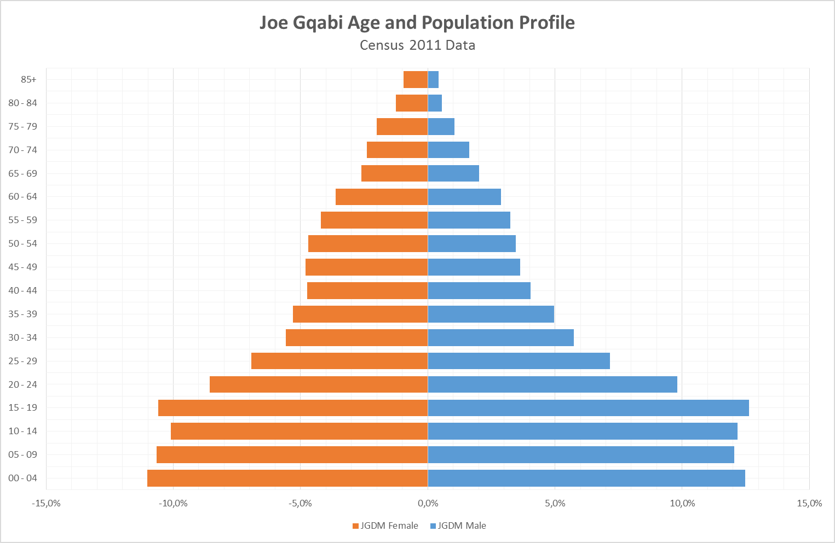

Should migration not be happening, the shape may portend an increased demand for housing and services over the next five years, as the retained young population would approach independence and require the provision of accommodation. The 2011 data shows that 56.3% of the JGDM population is younger than 25 years, with 47.8% younger than 20 years. This issue requires further interrogation in the IDP planning process.

Unemployment in the JGDM is very high. There are no recent figures available, but earlier indications are that 23.9%[5] of the population is unemployed. Data from Census 2011 indicated that 14% of the population was employed.

Table ‑: Unemployment Statistics from Census 2011

|  |  |
| --- | --- |
| **Economically Active Population** | **Fraction** |
| Employed | 53,9% |
| Unemployed | 29,5% |
| Unemployed and Discouraged | 46,1% |

The above table from Census 2011 suggests that unemployment is at 29.5% based on the narrow definition and 46.1% based on the broad definition, based on the economically active population. These figures are above the national average of some 25%[6].

## Migration

Migration occurs on a number of levels in the social landscape of South Africa. People move in and out of rural villages for a number of reasons. Economic reasons (employment) has led to people leaving rural areas for work opportunities in the larger urban nodes. Smaller urban nodes serve as temporary staging areas before more permanent moves to the larger urban nodes. Migration statistics have not been interrogated in detail in the compilation of this year’s WSDP, but this phenomenon will be assessed in the following IDP preparation process. It is assumed that there will be a general out-migration of people from the JGDM area, hence growth rates are accepted to be very low over the planning horizon of 30 years.

It must however be borne is mind that cultural custom leads to a seasonal migration pattern where people from urban areas migrate back to traditional homesteads in the summer and Easter holidays. This often leads to spikes in the demand for services in the December and March/April periods. Designs must therefore allow for these peaks through appropriate peak factors.

## Population Growth

The population growth rate for the all municipalities and specifically the rural and urban components was derived from the 2001 and 2011 census data.

|  |  |  |
| --- | --- | --- |
| **Local Municipality** | **Urban Growth** | **Rural Growth** |
| Elundini | 1,00% | 0,05% |
| Senqu | 0,05% | -0,12% |
| Gariep | 0,73% | 0,00% |
| Maletswai | 1,60% | 0,00% |

This information was used to do all projections and assessments with respect to demand, effluent flows and capacities of treatment works. It is evident that population growth is low. The rural growth is negative for Senqu. Maletswai experiences the highest growth rate.

# Backlogs

The JGDM area still experiences substantial basic services backlogs. It is therefore an imperative to devise and implement strategies and projects to eradicate backlogs as soon as is practicable.

## Water Backlogs

The water backlogs, derived from the Census 2011 data and extrapolated to 2015 are depicted in the tables below for each LM area.

Table ‑: Water Backlogs in Elundini

|  |  |  |  |  |  |
| --- | --- | --- | --- | --- | --- |
| **Consumer Category** | **None or inadequate** | **Communal water supply** | **Uncontrolled volume supply: yard tap or house connection** | **Grand Total** | **Backlog per Category** |
| Non-Residential | 132 | 167 | 257 | 556 | 0,7% |
| Farms | 451 | 65 | 245 | 761 | 2,5% |
| Urban | 2 985 | 3 441 | 5 149 | 11 575 | 16,8% |
| Rural | 14 230 | 9 797 | 1 010 | 25 038 | 80,0% |
| Grand Total | 17 799 | 13 470 | 6 661 | 37 930 | 100,0% |
| Percentage | 46,9% | 35,5% | 17,6% | 100,0% |  |

The Elundini LM area has a very large rural component, with relatively smaller urban nodes and rural villages with a communal land tenure system. There is a large number of villages with relatively low density in each village, scattered over an extensive area. Livelihoods are characterised as subsistence with a relatively high social grant dependence. 80% of the total backlog is rural, followed by urban and farms. This has implications for the type of infrastructure that must be planned for in eradicating the backlog, levels of service and operations and maintenance strategy.

Table ‑: Water Backlogs in Senqu LM

|  |  |  |  |  |  |
| --- | --- | --- | --- | --- | --- |
| **Consumer Category** | **None or inadequate** | **Communal water supply** | **Uncontrolled volume supply: yard tap or house connection** | **Grand Total** | **Backlog per category** |
| Non-Residential | 48 | 55 | 282 | 384 | 0,7% |
| Farms | 275 | 238 | 1 297 | 1 809 | 3,8% |
| Urban | 63 | 1 143 | 4 782 | 5 987 | 0,9% |
| Rural | 6 759 | 13 703 | 9 220 | 29 682 | 94,6% |
| Grand Total | 7 145 | 15 139 | 15 580 | 37 863 | 100,0% |
| Percentage | 18,9% | 40,0% | 41,1% | 100,0% |  |

As with Elundini. The Senqu LM has a high rural component, with a similar profile to Elundini. Land is communally held, and settlement patterns are sparse without a defined form or structure. The incidence of public services is low and under development, with some backlogs in all services. The backlog is almost entirely rural (94.6%) with 40% of total households without an adequate level of service.

Table ‑: Water Backlogs in Maletswai LM

|  |  |  |  |  |  |
| --- | --- | --- | --- | --- | --- |
| **Consumer Category** | **None or inadequate** | **Communal water supply** | **Uncontrolled volume supply: yard tap or house connection** | **Grand Total** | **Backlog per category** |
| Non-Residential |  |  | 234 | 234 | 0,0% |
| Farms | 99 | 207 | 849 | 1 154 | 41,0% |
| Urban | 143 | 2 106 | 9 262 | 11 509 | 59,0% |
| Rural | 0 | 0 | 0 | 0 | 0,0% |
| Grand Total | 242 | 2 312 | 10 345 | 12 897 | 100,0% |
| Percentages | 1,9% | 17,9% | 80,2% | 100,0% |  |

Maletswai LM is characterised by a high incidence of private land ownership in a rural context, with farming (stock mainly and limited cropping). There are defined urban nodes with very sparse non-urban population distributions. There is no rural household residential section or sector and farms make up the rural component. The backlog is very small and urban.

Table ‑: Water Backlogs in Gariep LM

|  |  |  |  |  |  |
| --- | --- | --- | --- | --- | --- |
| **Consumer Category** | **None or inadequate** | **Communal water supply** | **Uncontrolled volume supply: yard tap or house connection** | **Grand Total** | **Backlog per Category** |
| Non-Residential | 1 |  | 16 | 18 | 0,5% |
| Farms | 63 | 213 | 1 145 | 1 421 | 32,8% |
| Urban | 128 | 94 | 8 400 | 8 620 | 66,7% |
| Rural |  |  |  |  | 0,0% |
| Grand Total | 191 | 307 | 9 561 | 10 058 | 100,0% |
| Percentages | 1,9% | 3,1% | 95,1% | 100,0% |  |

As with Maletswai, Gariep has a similar characteristic of commercial/private land ownership with small dense urban nodes with a rural character, mainly serving the needs of the farming sector. The backlog is very small and urban.

Table ‑: Water Backlogs in the JGDM area, consolidated

|  |  |  |  |  |  |
| --- | --- | --- | --- | --- | --- |
| **Consumer Category** | **None or inadequate** | **Communal water supply** | **Uncontrolled volume supply: yard tap or house connection** | **Grand Total** | **Backlog per Category** |
| Non-Residential | 181 | 222 | 789 | 1 192 | 0,7% |
| Farms | 887 | 723 | 3 536 | 5 147 | 3,5% |
| Urban | 3 318 | 6 784 | 27 593 | 37 695 | 13,1% |
| Rural | 20 990 | 23 500 | 10 230 | 54 719 | 82,7% |
| Grand Total | 25 377 | 31 228 | 42 148 | 98 753 | 100,0% |
| Percentages | 25,7% | 31,6% | 42,7% | 100,0% |  |

The overall picture for the JGDM indicates a water supply service backlog of 25.7%, with 31.6% on standpipe supplies and 42.7% on a high level of service. The incidence of the backlogs is 82.7% in the rural areas, with 13% in the urban areas. The persistence of the rural backlog is influenced by the spatial form and the cost of the provision of rural services, where economies of scale are difficult to achieve and the logistics are a significant challenge.

## Sanitation Backlogs

Sanitation has generally been worse-off in the country than water supply services. The picture in the JGDM is similar to the national profile. The tables below provide a statistical view of the provision of services according to the Census 2011, projected top 2015.

Table ‑: Sanitation Backlogs in Elundini LM

|  |  |  |  |  |  |  |
| --- | --- | --- | --- | --- | --- | --- |
| **Elundini** | **No Service** | **Below RDP** | **RDP** | **Above RDP** | **Total** | **Backlog per Category** |
| Rural | 6 704 | 10 796 | 6 735 | 1 133 | 25 368 | 78,2% |
| Urban | 1 428 | 3 462 | 2 381 | 4 038 | 11 309 | 21,8% |
| Total | 8 132 | 14 258 | 9 116 | 5 171 | 36 677 | 100,0% |
| Percentage | 22,2% | 38,9% | 24,9% | 14,1% | 100,0% |  |
| Cumulative | 22,2% | 61,0% | 85,9% | 100,0% |  |  |

The table above shows that 61% of households in Elundini are below the RDP level in terms of sanitation provision. The rural areas in the LM account for 78.2% of the sanitation services backlog. The urban backlog is also very high, making up 21.8% of the backlog, and 13.3% of all households.

Table ‑: Sanitation Backlogs in Senqu LM

|  |  |  |  |  |  |  |
| --- | --- | --- | --- | --- | --- | --- |
| **Senqu** | **No Service** | **Below RDP** | **RDP** | **Above RDP** | **Total** | **Backlog per Category** |
| Rural | 3 626 | 10 464 | 9 067 | 1 702 | 24 859 | 75,2% |
| Urban | 1 353 | 3 286 | 1 475 | 4 941 | 11 055 | 24,8% |
| Total | 4 979 | 13 750 | 10 542 | 6 643 | 35 914 | 100,0% |
| Percentage | 13,9% | 38,3% | 29,4% | 18,5% | 100,0% |  |
| Cumulative | 13,9% | 52,1% | 81,5% | 100,0% |  |  |

Senqu LM has a similar profile to Elundini, with a slightly lower backlog at 52.1% as opposed to 61%, with a similar rural/urban split. The urban backlog is also very high at 24.8% of the backlog, comprising 12.9% of all households.

Table ‑: Sanitation Backlogs in Maletswai LM

|  |  |  |  |  |  |  |
| --- | --- | --- | --- | --- | --- | --- |
| **Maletswai** | **No Service** | **Below RDP** | **RDP** | **Above RDP** | **Total** | **Backlog per Category** |
| Rural | 0 | 0 | 0 | 0 | 0 | 0,0% |
| Urban | 865 | 690 | 378 | 9 098 | 11 031 | 100,0% |
| Total | 865 | 690 | 378 | 9 098 | 11 031 | 100,0% |
| Percentage | 7,8% | 6,3% | 3,4% | 82,5% | 100,0% |  |
| Cumulative | 7,8% | 14,1% | 17,5% | 100,0% |  |  |

The sanitation service profile for Maletswai is substantially better than the predominantly rural LM’s of Elundini and Senqu, with 14.1% of households with an inadequate sanitation service. There is no rural backlog, and the urban backlog is relatively high at 14.1% of total households, a similar fraction to the rural LM’s.

Table ‑: Sanitation Backlogs in Gariep LM

|  |  |  |  |  |  |  |
| --- | --- | --- | --- | --- | --- | --- |
| **Gariep** | **No Service** | **Below RDP** | **RDP** | **Above RDP** | **Total** | **Backlog per Category** |
| Rural | 0 | 0 | 0 | 0 | 0 | 0,0% |
| Urban | 181 | 753 | 62 | 7 398 | 8 394 | 100,0% |
| Total | 181 | 753 | 62 | 7 398 | 8 394 | 100,0% |
| Percentage | 2,2% | 9,0% | 0,7% | 88,1% | 100,0% |  |
| Cumulative | 2,2% | 11,1% | 11,9% | 100,0% |  |  |

Gariep LM has the better comparative profile of the JGDM LM’s, with the lowest overall backlog. It is similar to Maletswai, with no rural backlogs, and the urban backlog comprising a relatively high 11.1%.

Table ‑: Sanitation Backlogs in the JGDM Area Consolidated

|  |  |  |  |  |  |  |
| --- | --- | --- | --- | --- | --- | --- |
| **Joe Gqabi DM** | **No Service** | **Below RDP** | **RDP** | **Above RDP** | **Total** | **Backlog per Category** |
| Rural | 10 330 | 21 260 | 15 802 | 2 835 | 50 227 | 72,4% |
| Urban | 3 827 | 8 191 | 4 296 | 25 475 | 41 789 | 27,6% |
| Total | 14 157 | 29 451 | 20 098 | 28 310 | 92 016 | 100,0% |
| Percentage | 15,4% | 32,0% | 21,8% | 30,8% | 100,0% |  |
| Cumulative | 15,4% | 47,4% | 69,2% | 100,0% |  |  |

The consolidated picture for the JGDM reflects a very high backlog of 47.4% for sanitation, with a disproportionate incidence in the rural areas, but the urban areas are still relatively high at 27.6% of the total backlog, with 13.1% of urban households with an inadequate sanitation service.

### Bucket Eradication

JGDM still has bucket toilets serving some households. The numbers recorded in 2011 are reflected in the table below. There has been provision made for bucket eradication in JGDM (specifically Steynsburg) through the Department of Human Settlements. This project was completed recently. There are still bucket systems in Barkley East and xxxxxx

Table ‑: Incidence of Buckets in JGDM as at 2011

|  |  |  |  |  |
| --- | --- | --- | --- | --- |
| **Local Municipality (Category B)** | **Bucket toilet** | **% Buckets in LM** | **% of Total Buckets** | **% of HH in JGDM** |
| EC141: Elundini | 268 | 0,7% | 15,5% | 0,3% |
| EC142: Senqu | 645 | 1,7% | 37,3% | 0,7% |
| EC143: Maletswai | 70 | 0,6% | 4,0% | 0,1% |
| EC144: Gariep | 747 | 7,6% | 43,2% | 0,8% |
| **Grand Total** | **1 730** | **1,8%** | **100,0%** | **1,8%** |
| Total JGDM HH (2011) | 97 775 |  |  | 100% |

Bucket eradication funds through a specific programme is scheduled to be discontinued. Other funding streams will need to be accessed to deal with remaining buckets. The extent of buckets at present must be enumerated.

# Strategies to Eradicate Backlogs

It will be very good if the backlogs eradication programme is encapsulated in a plan with firm deadlines, as the initial deadlines set out in the SFWS have not been met in the JGDM. The National Development Plan (NDP) and the Medium Term Strategic Framework (2014 – 2019) have some targets for dealing with service levels.

## Water

The picture in the water supply services is relatively better than the sanitation services, but is still unacceptably high at 25.7%. Firm measures are underway, and a consolidated documented strategy will assist greatly, underpinned by a master plan. The key constraint relates to capital availability and information with respect to source availability and sustainable yield. The settlement patterns also present unique challenges, as economies of scale are difficult to plan for and achieve. The remoteness from key economic centres also means that construction costs will be higher than those in or near large urban centres.

## Sanitation

Sanitation services carry the brunt of the backlog at a very high 47.1%, and as with water supply services, a documented strategy, underpinned by a documented master plan will be very ideal.

The impediments to the eradication of the backlogs are mainly financial, but there are also structural elements in the spatial domain and the logistics of the deep rural areas, similar to the challenges to eradicate the water backlogs. The VIP is still the default sanitation solution with higher levels of service, associated with an outside or in-house waterborne option as the other and aspirational goal of all households.

The concern with on-site sanitation, and VIP’s in particular, is what happens when the pit fills up in five to ten years. Various options have been investigated and solutions are premised on mobility of the super structure, involving the excavation of a new pit and relocating to super structure to it. Other options with limited success or acceptability involve emptying pits and Urine Diversion (UD) solution with composting of the stabilised excrement. The Department of Water and Sanitation is in the process of investigating newer technologies. These may take a while be gain acceptance, but offer solutions to the current concern with respect to what happens when a VIP is full. One such possibility is the Earth Auger Sanitation system from the Bill and Melinda Gates Foundation. The JGDM should venture as a test site for these toilets.

Figure ‑: The Earth Auger System

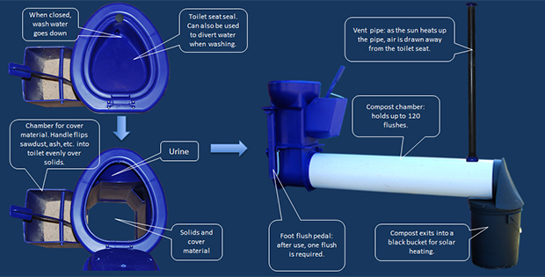

This system produces a usable compost and obviates the need to move the latrine in the future.

The worst (and possibly realistic) case scenario involved the resupply of a new sanitation structure at some point between 10 to 15 years of the initial installation. This scenario presents a substantial conundrum for local government and the fiscus if it were to eventuate. It is important to be constantly scanning for alternatives to the current VIP systems.

On-site Sanitation has moved from the ambit of the DWS to the Department of Human Settlements (DHS) between 2009 and 2014. The Service has been reallocated back to the DWS from 2014. The impact of this shift on sanitation delivery is not known yet.

## Concerns and thoughts to improve backlog eradication

The difficulty in eliminating basic services backlogs is affected by the following

* Definitive enumeration and high starting backlogs
* Remoteness of beneficiaries from key business centres
* Cost escalation
* Capital grants in relatively small annual tranches
* Protracted planning processes
* Protracted procurement processes
* Multiple objectives
* Inadequate funding
* Difficult terrain
* Inadequate raw water resources (surface and groundwater)
* Levels of services demanded
* Coordination challenges between organs of state
* Availability of skilled staff
* Availability of competent contractors
* Illegal connections and upgrades

There are general constrains, some of which are receiving attention from various angles and also identified in the National Development Plan. The institutional challenges can take time to change. The physical/technical challenges and initiatives that will improve backlog eradication and sustainability are listed below:

* Resource Development
  + Water Conservation and Water Demand Management
  + Surface resources
  + Boreholes and Springs
  + Rainwater Harvesting
* Development and extension and refurbishment of WTW and WWTW
* Maintenance, extension of Reticulation systems
* Development of wastewater collection systems
* Alternative on-site sanitation
* Coordination of plans and designs
* Improvement of existing services
* Ring-fenced budgeting and operations

The JGDM has already undertaken extensive planning work. The challenge is to increase budgetary allocations and setting up dedicated implementation unit(s) that focus intensively on dealing with backlogs and the coordination challenges along the full value chain of infrastructure provision.

# Water Services Resources

The JGDM area is endowed with surface and subterranean water resources. Surface water resources are in the form of rivers and dams established to utilise surface waters. Subterranean waters manifest in boreholes and springs that are harnessed to supply communities with water. The DWS has undertaken Reconciliation Strategies for a number of human settlements in the country and in the JGDM area. The information in these strategies has been gleaned from desktop exercises comprising WSDP’s and other information sources. The information needs to be updated at various stages in the planning cycle. It is recommended that the JGDM undertakes detailed master plans for various areas in its jurisdiction. These master plans will set and recalibrate resource levels against demand projections. Master Plans will also assist with finalising strategies for the eradication of backlogs and the setting of realistic and sustainable service levels for the current and future settings.

Substantial work has been undertaken in the 2010/2011 WSDP, which should be seen as the current standard, and be read in conjunction with the existing reconciliation strategies. The 2011 census data must be used to reassess population data and demands and this will be fed into revisions of future demand patterns over a 30-year planning horizon.

Under the auspices of the Rapid Response Unit of the DWS, Water and Sanitation Business Plans were undertaken for the JGDM area. Substantial information was gathered in this process and this information must be analysed and used to review the resource and demand versus capacity profiles for the municipality in the following three years.

## Surface Water Resources

JGDM has limited surface water resources. Reconciliation strategies have been developed for all the major towns in the DM, namely

* Steynsburg
* Burgersdorp
* Venterstad/Oviston
* Aliwal North
* Lady Grey
* Sterkspruit
* Herschel
* Barkley East
* Rhodes
* Ugie
* Maclear
* Mount Fletcher

The reconciliation strategies are largely desktop and some refinement of the work is required to improve the use of the documents for planning and decision making for the reconciliation and development of water resources.

### JG Water Resources

The eastern portions of JGDM fall within the Mzimvubu to Keiskamma Drainage Area. The rivers draining this area are designated as Quaternary Catchments xxx and xxx. The main rivers are the Tsitsa and the Thina, which form part of the Umzimvubu Drainage Area.

In the west, particularly in the Gariep LM, two sources of surface water are significant. These are the Orange-Fish transfer tunnel which has an abstraction for Steynsburg. Burgersdorp receives its water from the Stormsbergspruit. There are two dams and a run-of-river abstraction point. Venterstad and Oviston receive water directly from the Gariep dam. There is one water treatment works in Oviston that serves both Oviston and Venterstad. Steynsburg has a WTW in the town. Burgersdorp also has one WTW.

Aliwal North abstract water directly from a weir on the Orange River. Water is fed to a WTW that supplies the whole town. Jamestown receives water from a run-of-river abstraction from the Skulpspruit River that supplies an off-channel dam. There is one WTW that supplies the whole town of Jamestown.

Lady Grey receives water from two dams, namely the Lady Grey and Witfontein dams. There is a single WTW downstream of the dams that supplies the whole town

Surface water is the main water supply resource for the following urban and rural areas in the JGDM area. The table hereunder sets out the developed surface water resources for the JGDM area.

An important point regarding this table is the extent of unknown information with respect to yield, registered allocation and environmental allocation. This type of information is critical in understanding the sustainable operation of the surface water resources. The Mean Annual Runoffs are also required to understand the extent of future development of the resources, not only to support water for human consumptive needs, but also to gauge the extent to which water can support economic development in the other economic sectors of the area, and how best to balance these

Table ‑: JGDM Surface Water Resources[7]

|  |  |  |  |  |  |  |  |
| --- | --- | --- | --- | --- | --- | --- | --- |
| **TOWN/AREA** | **NAME OF WTW** | **LM** | **SOURCE TYPE** | **YIELD (Mℓ/d)** | **ALLOCATION (Mℓ/d)** | **IRRIGATION (Mℓ/d)** | **ENVIRONMENT (Mℓ/d)** |
| Maclear | AuCamp Dam | Elundini | AuCamp Dam Maclear Dam | 0.72 | 0.72 | No Data | No Data |
| Mooi River | Mooi River | 0.7 | 0.7 | No Data | No Data |
| Elundini rural Communities | Mt. Fletcher | Elundini | Mt. Fletcher Dam/Weir | 6.7 | 6.7 | 0 | 0 |
| Ugie | Ugie | Elundini | Ugie Dam | No Data | No Data | No Data | No Data |
| Wildebeest Weir | 6.0 | 6.0 | No Data | No Data |
| Lady Grey | Lady Gray | Senqu | Lady Grey Dam | 0,184 | 0,184 | 0 | No Data |
| Witfontien Dam | 0,022 | 0,022 | 0 | No Data |
| Sterkspruit | Sterkspruit | Senqu | Holohlatsi Dam | 22,027 | 11,507 | 8,685 | 5,836 |
| Sterkspruit Rural |  |  |  |  |  |  |  |
| Barkly East | Barkly and 8 Boreholes | Senqu | Langloof Weir & Commonage Dam | 1,3 | 1,3 | 0 | No Data |
| Rhodes | Rhodes | Senqu | Rhodes Dam | 0,3 | 0,3 | 0 | No Data |
| Aliwal North | Aliwal North | Maletswai | Orange River Weir | ? | 15 | 0 | 0 |
| Jamestown | Jamestown | Maletswai | Off Channel Dam | 1,172 | 1,172 | 0 | 0 |
| Steynsburg | Steynsburg | Gariep | Orange fish Tunnel, Gariep Dam | 347,9 | 4,383 | 0 | 0 |
| Oviston | Oviston WTW | Gariep | Gariep Dam | 5 | 5 | 0 | 0 |
| Venterstad | Oviston WTW | Gariep | Gariep Dam | 347,9 | 1,8 | 0 | 0 |
| Burgersdorp | Burgersdorp | Gariep | JL de Bruin Dam | 1,233 | 1,233 | 0 | 0 |
| Stormberg Spruit | No Data | No Data | No Data | No Data |
| Off channel Dam Chiappini's Klip Dam | No Data | No Data | No Data | No Data |

There may be scope for the further development of surface water to support the provision of basic water services and importantly, also to support further economic development that may lead to the creation of jobs in the area.

## Status of Surface Water Resources

There are limited large surface schemes in the JGDM area. The Gariep Dam is a major system, but does not supply a large population in JGDM. Most towns are reliant on relatively small dams and run-of-river systems and weirs. The JGDM experiences serious supply strain in drought conditions and some key dams are silted substantially.

### Gariep LM

The Gariep LM has 4 towns, namely Steynsburg, Burgersdorp, Venterstad and Oviston. Oviston, Venterstad and Steynsburg receive water from the Gariep dam, with the former drawing directly from the dam and treating for itself and Venterstad, while the latter draws water from the Orange-Fish tunnel some 25 km away and treating in the town. There is sufficient yield in this system to safeguard the supply to the three towns.

Burgersdorp draws water from the Stormsbergspruit.catchment. There is the JL de Bruin Dam on the Klein Buffelspruit River as the main supply which is augmented from the Chiapinni’s Klip Dam and a weir on the Stormsbergspruit. Chiapinni’s Klip is an off-channel dam receiving water from the Stormsbergspruit. This supply systems is under strain and some effort must be applied to improve the water supply to Burgersdorp.

### Maletswai LM

The Maletswai LM has two main towns, namely the larger Aliwal North and Jamestown. Aliwal North is a major centre and the largest urban area in the JGDM. Aliwal North receives water directly from a weir on the Orange River. High silt levels are a serious challenge in this systems. In 2015, severe supply conditions came into being. This has highlighted the need for storage dams to improve the risk of failure of the water supply to Aliwal North. The high siltation rates also need attention as it imposes additional costs in treatment and can lead to system failure.

Jamestown draws water via pumps from the Skulpspruit River and stores in an off channel dam. Water is treated and supplied to the whole of the town. This system has failed in the last xxxx years.

### Senqu LM

There are 5 towns in Senqu. The small hamlet of Rhodes has two supplies, namely the xxxx dam and the Bell River, a tributary of the Kraai River. Water is supplied from both these sources to a water treatment works. The dam is substantially silted and is an unreliable source of water. The Bell River is perennial and has not failed in the last xxx years. The safe yield of these systems are undocumented.

Barkly East draws water from a weir on the Langkloofspruit, a tributary of the Kraai River and from the commonage dam on the outskirts of the town. The commonage dam is small and received water as an off-channel storage from a pump station drawing from the Langkloofspruit and runoff from a small catchment. This system has failed in the last xxx years and is therefore a high risk. The yield of the system is undocumented. Boreholes have been developed as backup in case of drought.

Lady Grey has two storage dams, namely the aaaaa Dam and the bbbbb Dam. These dams are relatively small and have failed in the last xxxx years. The town has an existing WTW and a new one has been constructed, but the project came to a halt and has not been re-established. Storage volume needs to be developed or boreholes must be sourced to improve the assurance of supply.

Sterkspruit has two WTW and a number of boreholes. There is a main WTW in Sterkspruit that supplies the main town and some villages around Sterkspruit. Water is drawn from the Jozana Dam on the Sterkspruit River. The dam is substantially silted and the capacity of therefore reduced. This places the water supply system at a higher risk of failure in a drought event. The smaller xxxx WTW that supplies some rural villages receives water from the same Jozana Dam. The Sterkspuit WTW also supplies water to the small hamlet of Hershel.

### Elundini LM

Elundini LM does not have large water impoundments. The largest at present are the dam/weir on the Thina River from where water is drawn for treatment to supply Mt Fletcher and surrounding villagers. The storage consists of the Dam/weir and a holding dam prior to the water treatment works. The weir is substantially silted and does not have the initial storage as at design. The system is now susceptible to drought and has lost its ability to counteract low rainfall. This system needs serious attention.

Maclear is supplied from two dams and a run-of river abstraction. The dams are the aaa and the aaaa. Both dams are very small and are unable to withstand short return period risks. These dams have been drawn down in the recent past. The Mooi River WTW draws water directly from the Mooi River. This places this system at risk of failure in severe drought conditions.

Ugie draws water from a run-of –river abstraction point on the Inxu or Wildebeest River. This system has failed in the last xxx years and presents a long term supply risk for the town of Ugie. There is also a dam on the xxxxx River

## Subterranean Water

The remainder of the water demand of the JGDM area uses subterranean or groundwater water in the form of boreholes and springs.

The main aim in areas with insufficient water resources should be to use Groundwater water as far as practicable. Groundwater water, provided that there are no serious quality constraints, is generally more cost effective as treatment costs (capital and operational) are limited and affordable. It is therefore important for the sustainable capacity of the aquifers in the area to be known when determining the future or optimal water supply profile for the JGDM area.

The table below depicts the groundwater development and use profile in the JGDM. It is notable that yield and quality data for the various developed resources is not available. The JGDM area needs to expend some effort to determine and catalogue the safe yields of all boreholes in its jurisdictional area as this information is generally incomplete

Table ‑: JGDM Groundwater Resources[8]

|  |  |  |  |  |  |
| --- | --- | --- | --- | --- | --- |
| **LM** | **Area Name** | **Number of Production boreholes or springs** | | **Known Yield** | **Quality** |
| **Yield Known** | **Yield Unknown** | **(Mℓ/d)** |
| Senqu | Barkly East | 0 | 7 | 0 | ? |
| Lady Grey | 3 | 3 | 0,759 | ? |
| Herschel | ? | ? | 0,8 | ? |
| Rossouw | 0 | 3 | ? | ? |
| Rudimentary | ? | 54 | ? | ? |
| Elundini | Mt. Fletcher | 4 | 0 | 0,328 | ? |
| Ward 7 Rudimentary | 0 | 15 | 0 | ? |
| Rudimentary | 4 | 110 | 0,257 | ? |
| Maletswai | Jamestown | 8 | 0 | 0,41 | ? |
| Gariep | Burgersdorp | 13 | 0 | 0,41 | ? |
| Steynsburg | 9 | 0 | 0,908 | ? |

As groundwater is a viable source and supply proposition from the point of view of capital cost, development speed and generally more favourable operating cost, the full extent of this resource needs to be established urgently before a comprehensive backlog eradication plan can be formulated or implemented. Substantial effort has already been undertaken towards this by the JGDM in the Senqu area.

## Possible long term water supplies

### Mzimvubu River Water Resources Development

In 2007 ASGISA- Eastern Cape was formed to champion and drive the Mzimvubu River Water Resources Development (MRWRD) by the Eastern Cape Provincial Government. The rationale for this feasibility was to accelerate the social and economic upliftment of the people in the surrounding areas by harnessing the development potential of the Mzimvubu River system. This is the last major river system in South Africa that has no largescale impoundments or water supply schemes on it. The Feasibility Study for the Mzimvubu River Water Resources Development (October 2014, pg 1) has been completed and awaits implementation. This scheme has special focus in the country and has been designated as a SIP in the national infrastructure plan under the National Development Plan. The dam is expected to deliver water in the next 10 years. There is also a network of bulk distribution pump stations, pipelines and reservoirs that will supply a network of villages.

The focus of the study includes among other district municipalities the JGDM. The larger beneficiary is the OR Tambo DM and also the Alfred Nzo DM. Images extracted from the feasibility study indicating the boundary of the supply, the primary bulk portable water pipelines, pumping stations and command reservoirs and the supply zones for infrastructure planning are attached in **Annexure K.** Also included to this annexure is a list of the JDGM settlements that will benefit from this scheme. At present, no major towns in JGDM are included. The beneficiaries are rural villages in the Elundini LM. The main dam intended to supply JGDM villages is the Ntabelanga Dam on the Thina River.

### Orange River

The Orange River System is a significant water resource in South Africa. The drainage of JGDM in the western portion (the bulk of the drainage) forms part of MWA 13 (Upper Orange).The DWS has recently completed a reconciliation strategy for the Upper and Lower Orange schemes. The objective of that study is quoted below:

“*The objective of the study is to develop a reconciliation strategy for the bulk water resources of the Orange River System, to ensure that sufficient water can be made available to supply the current and future water needs of all the users up to the year 2040. This Strategy must be flexible to accommodate future changes in the actual water requirements and transfers, with the result that the Strategy will evolve over time as part of an on-going planning process*”

A set of reports have been produced and some recommendations have been made for further studies and yield balancing proposals.

The existing Orange River Project supplies water into the JGDM area through the Orange Fish River Tunnel. This is a conduit to supply irrigation needs and domestic needs down to Post Elizabeth. The Orange Fish River Tunnel is currently supplying the Steynsburg WTW with raw water. Oviston and Venterstad draw water directly from the Gariep Dam. These are the only urban areas in JGDM that benefit from the Gariep Dam. Aliwal North draws water directly from the river.

The executive summary of the reconciliation strategy for large bulk supply systems: Orange River makes reference to creating additional yield in the system by raising Gariep Dam by 10m or by building the Verbeeldingskraal Dam. The implementation date of either of these options will be dependent on the implementation date of the Ecological Preferred EWR, by approximately 2026. The decision is also contingent on another decision, namely the Feasibility Study outcome of the Vioolsdrift Dam in the lower Orange near the border with Namibia. **Annexure L** show the study area. The implications for the JGDM are as follows xxxxxxxxx

* The Kraai River appears to be fully covered in abstraction authorisations. It is also one of the last pristine rivers in the country with no impoundments developed on it. This status quo is proposed to be kept in place.
* While the Verbeeldingskraal dam is proposed upstream of Aliwal North, the dam’s certainty in unclear and subject to further studies and other feasibilities. Its timeline also appears to be beyond 10 years for decision making on whether it may happen. It will therefore not have an impact on immediate concerns.

The most prudent course of action is for the JGDM to compile its own motivations for water allocations and to take part in future discussions and planning initiatives in the area.

## Water Balance

The JGDM needs to undertake a comprehensive water balance exercise, reviewed on a regular basis in the future wherewith the municipality keeps track of water extracted and distributed against the resource capacity and yield. This will provide an indication of where and when resource development needs to be undertaken. A current project[9] is underway to develop a water loss or water balance on a monthly basis.

## Environmental Water Quality

The JGDM, in collaboration with the Department of Water and Sanitation, has a responsibility to monitor the water quality in rivers streams and operating aquifers, especially where household and industrial effluents are discharged into the environment.

# Wastewater Facilities

The JGDM has modern waterborne sanitation systems in all towns. Rural areas are generally served with household-based services.

## Wastewater Reticulation Systems

All the main towns in the JGDM either have full waterborne sanitation with a piped collection system of households have septic or conservancy tanks. There is a high incidence of septic and conservancy tanks in towns like Ugie, Mt Fletcher, Jamestown and Maclear. The ideal is to have a sewerage network as this has lower long term lifecycle costs. Vehicular collection is very expensive and can be more polluting to the environment as there is an incentive to minimize collection calls by overrunning systems.

One of the key infrastructure of the JGDM in the sanitation services will be the development of the sewerage network so that collection and disposal to works will be undertaken in a more passive and cost effective manner. Return flows conservation is important to balance the water resources and sewerage networks will play an important role in this instance in the country and the JGDM

Table ‑: Illustration of return flows in JGDM to the Upper Orange System[10]

|  |  |  |  |  |
| --- | --- | --- | --- | --- |
| **Sub-System** | **Description** | **2012 Gross demand (million m3/a)** | **2012 Return Flows (million m3/a)** | **Percentage Return Flow** |
| **Caledon** | Maseru | 14,264 | 1,82 | 12,80% |
| Ficksburg | 2,932 | 1,466 | 50% |
| Ladybrand | 2,688 | 0,533 | 19,80% |
| **Upper Orange** | Lady Grey | 0,281 | 0,141 | 50% |
| Aliwal North | 1,838 | 0,919 | 50% |
| Burgersdorp | 0,707 | 0,353 | 50% |
| Barkley East | 0,417 | 0,208 | 50% |
| **Riet/Modder** | Bloemfontein | 68,946 | 35,321 | 51,20% |
| Botshabelo | 9,625 | 4,139 | 43% |
| Thaba N'Chu | 4,846 | 2,423 | 50% |
| **Lower Orange Main Stem** | Upington | 14,644 | 5,222 | 35,70% |

The table above refers to return flows applicable to the Orange River system. The figures for Sterkspuit are not reflected here. The purpose is to raise attention to the extent in the JGDM area (50% of water demand) and the quantum thereof.

r

## Wastewater Treatment Works

The table below outlines the list of the JGDM wastewater treatment facilities, capacities and the areas they serve.

Table 10.3 JDGM Wastewater facilities

|  |  |  |  |  |  |
| --- | --- | --- | --- | --- | --- |
| AREA NAME | NAME OF WWTW | LM | SERVICE AREA | CAPACITY (Mℓ/d) | IRRIGATION (Mℓ/d)d) |
| Maclear | Maclear Activated Sludge | Elundini | Vincent and Greenfield | 750Kl/day being upgraded to 1400Kl/day | None |
| Maclear Ponds | Maclear hospital, high school hostel and 50 houses | 0.5 | None |
| Mt Fletcher | Mt Fletcher Ponds | Tsolobeg, Mfanta and town |  | None |
| Ugie | Ugie Ponds | Parts of town, factory | 0.7 | None |
| Prentjiesberg | Prentjiesberg village, truck stop, Ugie high school hostel, police station and boarding house. | 0.5 | None |
| Rhodes | No WWTW,  Septic Tank and conservancy tanks | Senqu | None | | |
| Barkly East | Barkly Old Ponds | Town | 0.73 | None |
| Barkly new Ponds | Nkululeko Location | 0.6 | 0.6 |
| Sterkspruit | Sterkspruit Ponds | Sterkpruit and surrounding settlements. | 2 | None |
| Lady Grey | Lady Grey Ponds | Lady Grey, Kwenzinaledi, Transwilger. | 2 | None |
| Herschel | Herschel Ponds | Herschel | 0.5 | None |
| Jamestown | Jamestown WWTW | Maletswai | Jamestown, Masakhane. | 0.75 | None |
| Aliwal North | Aliwal North WWTW | Aliwal, dukathole, River Lodge, Hilton. | 3.5 | None |
| Burgersdorp | Burgersdorp WWTW | Gariep | Burgersdorp Ereka Mzamomhle Thembisa  Harmonie | 2 | None |
| Oviston | Oviston WWTW | Oviston  CaravanPark | 0.2 | None |
| Steynsburg | Steynsburg WWTW | Steynsburg  Westdene Greenfields Khayamnandi | 1 | None |
| Venterstad | Venterstad WWTW | Venterstad  Nozizwe  Lyciumville | 1 | None |

Most of the towns in JGDM have at least one sewage treatment works. Only Rhodes and Rossouw do not have formalised WWTW. It is however important that even these settlements that do have septic and conservancy tanks have a formal facility for the disposal of sludge.

# Financial Profile

The financial profile of the JGDM consists of the capital programme and the operational budget. The operational budget should comprise the main budget of the municipality and the key tool that determines the sustainable delivery mechanism. The focus of municipal budgeting should in future be the operational budget, as in an ideal society where most households have sustainable and decent incomes, a municipality should be largely self-financed in terms of recurrent expenditure items and for refurbishment, augmentation and new capital investment. The legacy of our political past has created an environment wherein poverty has rendered large portions of our households without decent incomes, and therefore unable to fund municipal services without substantial support from the National Fiscus. It should be a long-term objective of all organs of state to create a future state where households have decent incomes and are able to afford a municipal service package. Currently, operational budgets are largely grant finance (Equitable Share) based, with service charges playing a small component of income and various statutory grants largely financing operations.

The capital budget comprises mostly statutory grants from the National Fiscus to cover the costs of services backlogs for households that do not have adequate access to basic services, however defined. The main source is the Municipal Infrastructure Grant (MIG), supported by other smaller grant sources. Few municipalities are able to manage capital programmes that are funded substantially from commercial or DFI loans, or from current income from service charges.

## Operating Budget

The JGDM presented an Excel Database with all the individual line items for water and sanitation income and expenditure. The source of information is known as the JGDM SAMRAS spreadsheet. The information has been rearranged and extracted to facilitate easier analysis of the various components of income and expenditure items. This is the only database available and actual expenditure information for prior years has not been availed yet. The operating budget of the JGDM Water and Sanitation functions is depicted in the graphics below:

Figure ‑: JGDM Income vs Expenditure

The graph above illustrates budgeted expenditure in excess of budgeted income.

The operating budget elements have been broken down into the following:

* Employee Expenses/Costs
* General Expenses
* Contracted Expenses
* Bulk Purchases

It will also be advisable that the operating budget be reflected in total for the JGDM Water and Sanitation operations separately and combined, but also for the Local Municipality areas and ultimately per system. It is also understood that a per-ward breakdown may also be required at some stage, although this is often difficult as ward boundaries can change with every election cycle. The Blue and Green Drop regulatory system, wisely so, views water and sanitation provision on a “system” basis, comprising for water

* Resource
* Treatment
* Distribution

And for the sanitation service:

* Collection
* Treatment
* Receiving Environment

There are definite benefits in perceiving the services in this framework and where possible, budgets should also be construed in this format for each system. This is currently not the case and must be considered by the JGDM.

Operating income is derived primarily from the Equitable Share. The JGDM has a tariff system in place, but income will mainly be a possibility in the urban nodes. Tariff recovery rates is not known at present and actual information is not available in SAMRAS.

## Other Key Budget Components

The personnel budget is a key component of an operating budget and some strategic choices must be made between the various key cost drivers and their proportion of the operating budget.

Figure ‑: JGDM Budget Structure for Water Supply Services

There are currently contracted services that are provided for in the operating budget. This will include the appointment of external service providers to undertake operational functions for the municipality. Sabata, a private company currently undertakes meter readings in Barkly East, Lady Grey and Aliwal North.

Contracted services are a small component of the Water Supply budget, at under 1% of the total budget. By contrast, contracted services are indicated to comprise more than 50% of the Sanitation budget. This scenario must be analysed and the value of such an arrangement verified. It is conceivable that contracted services may be a benefit, provided the value proposition is good.

Employee costs form a very high proportion of total expenditure for the Water Supply Service. This budget structure requires further enquiry to assess its appropriateness and sustainability. The staff component for sanitation is much lower. This could be due to a variety of factors. The high level of contracted services may be a contributing factor. This will have to be investigated further in the Water and sanitation Operational Business Plan.

Figure ‑: JGDM Budget Structure for Sanitation Services

The future sustainability of the service will be determined by the budget structure. The Strategic Framework for Water Services (SFWS) calls for the compilation and the annual revision of a Water Services Operations and Maintenance Business Plan (WSO&M BP). Such a document has been commenced by the JGDM, but it needs to be completed and used to guide budget structure.

## Capital Budget

The capital budget covers new works, refurbishments and upgrades to existing infrastructure.

## Sources of Capital

The current public sector sources of available capital for infrastructure creation and refurbishment comprise the following:

* Municipal Infrastructure Grant (MIG)
* Regional Bulk Infrastructure Grant (RBIG)
* The Municipal Water Infrastructure Grant (MWIG)
* The Rural Household Infrastructure Grant
* The Accelerated Community Infrastructure Programme (ACIP)
* The Refurbishment Grant
* COGTA grants

The MIG is statutory with a relatively high assurance that is published over the Medium Term Expenditure Framework (MTEF) over 3 years’ windows by the National Treasury under the Division of Revenue Act (DORA). The MIG is primarily for the provision of basic services (new works and upgrades) for indigent households. The MWIG and RHIG are also published over three years in DORA and cover new works and improvements/refurbishments. The other grant sources operate on a per project basis and the municipality competes with other municipalities for funding under these grants. The JGDM does make allowance for loan capital in its structure, but uptake of commercial loans have not been verified. The statutory funds available to the JGDM are as follows, according to the 2015/16 DORA Bill.

Table ‑: Capital Grants for the JGDM according to the 2016 DORA Bill



There are also other sources of grants from Sector Departments and external entities that may be accessed on an application basis to cover infrastructure and systems (“soft issues”). The JGDM has a list of projects that are to be funded by the Department of Cooperative Government and Traditional Affairs (COGTA). The Accelerated Community Infrastructure Programme (ACIP) grants project funding on a project-by-project basis, with annual applications. The JGDM will utilise these funding opportunities when they are available. There are no current projects that are funded from ACIP.

Table ‑: COGTA SDIP Capital Budget for JGDM as per IPP

|  |  |  |  |  |
| --- | --- | --- | --- | --- |
| **Service** | **Approved Budget** | **Projected Expenditure for 2015/2016 (incl. VAT)** | **Projected Expenditure for 2016/2017 (incl. VAT)** | **Projected Expenditure for 2017/2018 (incl. VAT)** |
| Total for Water | R 167 000 000 | R 37 000 000 | R 80 000 000 | R 50 000 000 |
| Total for Sanitation | R 33 000 000 | R 33 000 000 | R 0 | R 0 |
| **TOTAL** | **R 200 000 000** | **R 70 000 000** | **R 80 000 000** | **R 50 000 000** |

Indications are that R20million of funding was available from COGTA for the 2015/16 financial year. This must still be confirmed.

The current IPP of JGDM reflects the following investment plans, funded from the currently available grants.

Table ‑: JGDM Infrastructure Implementation Plan Water Services Planned Investments

|  |  |  |  |
| --- | --- | --- | --- |
| **Water Service Category** | **Projected Expenditure for 2015/2016 (incl. VAT)** | **Projected Expenditure for 2016/2017 (incl. VAT)** | **Projected Expenditure for 2017/2018 (incl. VAT)** |
| Total for Water | R 65 700 000 | R 75 000 000 | R 89 867 000 |
| Total for Sanitation | R 103 470 000 | R 75 541 100 | R 70 000 000 |
| **Total** | **R 169 170 000** | **R 150 541 100** | **R 159 867 000** |

The IPP project totals are lower than the DORA allocations. Some of the difference will go towards operational funding of the PMU.

JGDM has also successfully sourced grant funding from ORIO. Orio is a Facility for Infrastructure Development that is managed by the Dutch Ministry of Foreign Affairs.

## Water Services Backlog Eradication Possible Timelines

Most municipalities that started with high water services backlogs have had difficulty in eradicating the backlogs, especially meeting the initial deadlines that were stated in the SFWS. Timelines and targets have been in place since 1994, although they have not been met over the last 21 year period. Targets are nonetheless important as they serve to focus effort and the problem with backlogs in important enough to warrant expedition.

Some conceptual scenarios are presented hereunder, where the entire annual MIG allocation to the JGDM (assumed to grow at 5% per year henceforth), or 72% thereof, are presented. These are as in 2015.

Figure ‑: Backlog Eradication against annual MIG Requirement

With all of the MIG budget allocated to water services backlog, it is estimated that the backlog could be eradicated by 2023. This assessment takes into account a 5% growth rate in the MIG allocations and contract price escalation applied to the remaining backlog on an annual basis at 10%.

No other sources of capital have been taken into account. Doing so can reduce the time needed to eradicate the backlog. Other logistical issues, as listed below have not been taken into account:

* Availability of contractors
* Material availability and logistics
* Planning and Design
* Procurement
* Community interaction and approvals

These factors can retard progress substantially, but in themselves can also be optimised to achieve an accelerated backlog eradication programme. The graph below presents the MIG allocation cumulatively over the backlog eradication period, with an initial backlog of R1.03 billion, and with an anticipated spend of approximately R1.7 billion to eradicate the backlog, escalation considered.

Figure ‑: Outstanding Backlogs against Capital Requirement over time

While the above graph assumes that all available MIG funding is expended on water and sanitation, the graph below assumes that only 72% of the MIG budget is allocated to the eradication of the backlogs, as there are competing needs for the MIG, covering other services within the responsibility of the JGDM and the cost of PMU and PIU functions. This guideline of 72% is based on the initial stance with the inception of the MIG and the eradication targets set out in the SFWS, which stipulated eradication targets of 2008 for basic water supply service backlogs and 2010 for basic sanitation service backlogs.

Figure ‑: MIG Allocations at 72% against the Backlog Burden over time

The timeline to eradicate the backlog stretches to about the year 2027/28. This set of scenarios can assist with strategies of capital allocation within the municipality. The analysis illustrates that backlog eradication is possible, but requires adequate time, finance and also some institutional re-alignment and coordination with possible external stakeholders.

Figure ‑: Backlog Eradication need against Capital Requirements over time

The cumulative anticipated MIG expenditure, taking escalation into account, yields an allocation of R1.98 billion to eradicate the backlog

Further to the above and based on the Dora Bill of 2016, the following scenarios are presented for further discussion:

Figure ‑: Recent (2016) Backlog Eradication Scenarios

The graphic above takes account of recent published RBIG approvals for the Sterkstroom water supply project. JGDM is also expected to receive allocations from the Water Services Infrastructure Grant. This increases allocations substantially for water and sanitation projects. No other sources capital have been incorporated, although these can and do feature. Examples are the COGTA funding, funds from Orio and possibilities for ACIP and other specific grants. The graphic assumes MIG allocations to Water and sanitation projects ranging from 100% of total MIG per year to 50%. Should funding be maintained at these levels, it is conceivable to eradicate backlogs of R1.02 billion between 2020 and 2023.

The MIG MTEF allocations have also changed from the ones published in 2015. The changes are depicted below.

Figure ‑: Comparison between MIG MTEF allocations over two budget cycles

This graph shows a reduction in allocations and growth compared to that envisioned in 2015. This must be borne in mind for projections beyond the immediately ensuing year and future periods.

## Budget Reforms

The National Treasury has undertaken a project to reform public Sector Budgets and standardize them across the various spheres and organs. The Standard Chart of Accounts (SCOA) framework will be implemented in the current financial year. The implications of this migration to SCOA will be clarified in the course of the 2015/16 financial year and the material impact it will have on the Water and Sanitation Budget framework.

There is a need to redesign the Water and sanitation Budgets of JGDM. It is not easy to track expenditure and to link expenditure with cost centres. This makes it difficult to analyse budgets and to improve budgeting.

# Status of Water Services Infrastructure

The status of the water services infrastructure of the JGDM is dealt with in the asset register which has been developed recently. This will be dealt with in more detail in the W&S Operational and Maintenance Business Plan. For the purposes of the WSDP, existing infrastructure that predates the advent of liberation is accepted as being in a tenuous state. A programme is required to refurbish and augment this infrastructure base to extend its lifespan. The structure of the capital budget already makes provision for refurbishment using COGTA grants and some MIG funding. New infrastructure implemented since 1994 is generally serviceable save for cases of defective construction. The extent of infrastructure requiring refurbishment will be reported on in greater detail in the 2016/16 WSDP.

The capacities of most of the Water Treatment Works (WTW) and Wastewater Treatment Works (WWTW) have been assessed in the context of current theoretical demand and planned demand at the planning horizon of 30 years hence. These are depicted graphically in **Annexures B to I**. It is good practice to maintain a 15 % reserve on all treatment facilities to make up for peak periods, unexpected additions and for taking unit operations off-line for maintenance.

## Visual Inspection of Water Treatment Facilities

The status of water production facilities were evaluated at a high level and the following can be reported as the current status quo

### Elundini LM WTW

The works in Mt Fletcher is new, having been commissioned in 2011. This is a conventional rapid gravity treatment works with a raw water holding dam, coagulation/flocculation, longitudinal settlers and rapid gravity sand filters. The final water is disinfected and mostly pumped away. The supply to the works is all pumped. The biggest concern at this stage is the throughput constraints in the flow channels from the settling plant to the filters. At present, the launders overflow when the flows exceed xxxx ℓ/s.

Maclear has two WTW. The Mooi River WTW is a package plant drawing run-of-river flows from the Mooi River. This plant is situated to the south of the town. The works are housed in containers. The works are currently being upgraded from xxxxx Mℓ/d to xxxx Mℓ/d. The upgrade is incomplete and expected to be completed by xxxxxx. Funding is available in the xxxxx financial year. The treatment process is conventional with coagulation/flocculation, settling, pressure filtration and disinfection. There is no washwater recovery and the works have some leaks in one of the pump sumps (JoJo Type). All raw water is pumped to the works and final potable water is all pumped away. The other works is the Aucamp WTW situated to the north of the town. These works are old (in excess of xxx years) and in need of some refurbishment to maintain the ability to supply in the long run. This process is also conventional with coagulation/flocculation, settling, pressure filters and disinfection. Water is pumped from the xxxx dam and is received from the xxxx dam via gravity. All final water is gravitated to the supply areas.

Ugie has one WTW, named the xxxx WTW. The works are situated to the south of the town and can treat xxxx Mℓ/d. The works are conventional with coagulation/flocculation, longitudinal settlers, pressure filtration and disinfection. Final water is pumped to supply areas.

### Senqu LM WTW

There is one WTW in Barkly East. The works receives water from a pump station that draws from the Langkloofspruit. The works are generally old, having been originally built in aaaaaa. The process is conventional with coagulation/flocculation, longitudinal settling followed by pressure filtration. The filters have recently been upgraded with larger pressure filters. Final water is disinfected before it is pumped to distribution reservoirs. There is no washwater recovery.

Rhodes has a single WTW that draws water from the Bell River via pumping. Water is also drawn from a dam upstream of the works through gravity. The works are conventional package plant type with coagulation, limited flocculation, pressure sand filtration and disinfection. Final water is pumped to a header reservoir from where it is fed to the supply zones via gravity. There is no wash water recovery.

Lady Grey has an operating package plant-type WTW. This plant is relatively old and situated in a crammed building. It receives water via gravity and the final water is distributed via gravity. A new works has been constructed, but the contract has been suspended. The new works will have a capacity of xxxx Mℓ/day when completed. The unit operations are of the package format with pressure sand filters. The other process are conventional, with the final water intended to be disinfected. There is no allowance for washwater recovery.

Sterkspruit has two WTW. The main works is the xxxxx WTW situated in the town of Sterkspruit, towards the west of the town. The works has recently been upgraded to a capacity of xxxx Mℓ/day. It is of conventional concrete construction with coagulation/flocculation, settling, rapid gravity filtration and disinfection. The treated water is distributed through pumping and gravity. Raw water is supplied from the Jozana Dam via gravity. No washwater recovery facilities have been provided. The main works supplies water to the settlement of Herschel as well. There is a smaller xxxxx WTW that supplies water to rural villages. The works draws water via gravity from the Jozana Dam. The works are convention package type with pressure filtration. The treatment processes entail coagulation/flocculation, settling, pressure filtration, disinfection and distribution via pumping. There is no washwater recovery.

### Maletswai LM WTW

Maletswai has two towns, namely Aliwal North and Jamestown. Aliwal North has one WTW of a conventional construction. The works comprises a balancing dam, coagulation/flocculation, settling, rapid gravity filtration and disinfection. Final water is distributed via pumping. Raw water is all supplied via pumping. There is no washwater recovery. The works are old, approximately xxx years. The works needs to be prioritised for renewal/upgrading.

Jamestown has a package-type works with coagulation/flocculation, settling, pressure sand filtration and disinfection. Raw water is all pumped to the works and final water is pumped away for distribution. There is no washwater recovery. There is no immediate visual problems at these works.

### Gariep WTW

Burgersdorp in the Gariep LM has one WTW, the xxxx WTW. The works is old with conventional processes. There is coagulation/flocculation, settling, rapid gravity sand filtration and disinfection. All raw water is received via pumping and final water is gravitated away. The works are strained by a high loading of silt. These works need to be prioritised for renewal/upgrading. There is no washwater recovery.

Steynsburg has one WTW that receives water from the Orange-Fish transfer tunnel. It is relatively new and of an all concrete construction. The processes are conventional with coagulation/flocculation, settling, rapid gravity sand filtration and disinfection. Final water is distributed via gravity. There is a washwater recovery section. The works are visually in a good state.

Venterstad and Oviston are supplied from one WTW situated in Oviston. The works receives water from the Gariep Dam via pumping. The works are old, dating to circa 1968. The works are of brick/concrete construction with a balancing dam, coagulation/flocculation, rapid gravity sand filtration and disinfection. Final water is distributed via gravity and pumping. There is no washwater recovery. The works must be prioritised for refurbishment and upgrading.

### General Perspectives of JGDM WTW

It is important for a central repository to be created where all information of the works are stored. This must include

* Design reports
* Drawings
* Process audits
* Operational and compliance monitoring
* Water Safety Plans
* Incidence Reports
* Emergency Response plans

The WSA and WSP functions can each host this information.

Washwater recovery must be considered at all works, as this is a good example of water conservation.

## Visual Inspection of Wastewater Treatment Facilities

The JGDM has several WWTW and these have been visually assessed for reporting in the WSDP.

### Elundini WWTW

***Mt Fletcher*** has one WWTW. Households have septic and conservancy tanks. The WWTW can receive waterborne effluent. The inlet works, however has not been designed to receive regular waterborne effluent as there are no screening and degritting facilities. The WWTW uses oxidation pond technology. Final effluent is not formally disinfected, but more on an informal basis. The pond walls are breaching and effluent informally leaves the works into the environment. The works are fenced and access is controlled. Effluent is received via tanker and final effluent, although not meant to leave as the works operate as evaporation ponds, does leave. The works do not have a formal final effluent discharge point.

***Maclear*** has two sewage treatment facilities. There is the older pond based WWTW to the north of the town. This system is also meant to act as an evaporation pond. The effluent does however breach the pond walls. The treatment technology consists of screening and oxidation ponds. The works are meant to be abandoned in the future and the sewage currently received will be redirected to the xxxxx WWTW. The access road to this plant is problematic and needs to be improved. The xxxx WWTW is situated on the south of the Maclear along the xxxx road. The works uses activated sludge as the treatment technology. The works consists of an inlet works with screening and degritting, an extended aeration basin with anoxic zones. The final effluent is disinfected before being released to the Mooi River. The works are currently undergoing an upgrade, where the capacity is being increased from the current xxxx to xxxxMℓ/day. The same activated sludge treatment technology is utilised. Both works are well-fenced with controllable access.

***Ugie*** also has two treatment works. There is the xxxxx WWTW to the east of the works and the xxxxx WWTW to the south of town. The xxxxx WWTW used oxidation pond technology and accepts tankered effluent only. The capacity of the works is xxxx Mℓ/day. The works are fenced. It is planned that the works will be phased out and sewage will be redirected to the xxxx WWTW. The access road to this WWTW needs serious improvement as it is not easily negotiable, even by vacuum tankers. The works are properly fenced with controllable access. The Prentjiesberg WWTW is situated to the south of town. The works uses the sequential batch technology (SBR), an activated sludge treatment system. The heart of the plant is a steel structure wherein all the key processes, namely secondary treatment (aeration) and settling is undertaken. Final effluent is disinfected before it is released to the xxxx River. A large number of households use septic and conservancy tanks at present. The capacity of the works is expected to increase once a reticulation system is installed.

### Senqu WWTW

***Rhodes*** does not have any WWTW and most households use septic tanks. Septic tank effluent, however, still needs to be disposed of safely and a form of formal treatment facility may still be required.

***Barkly East*** has two pond based WWTW. The older xxxxx works has a capacity of xxx Mℓ/day and it situated towards the east of the town. These works consist of an inlet works, allowance for the accommodation of buckets, an anaerobic pond (2 in parallel), oxidation ponds and maturation ponds. The works does not have a disinfection unit. There is evidence of pond breach and high operating levels. This suggests that the works need refurbishment/upgrading and/or operational changes. A process audit would point out any limiting components in the current process set-up.

The second works in Barkly East is situated to the north of the town. The works is referred to as the xxxx WWTW, with a treatment capacity of xxxxMℓ/day. These works have been designed to irrigate all the effluent on adjacent land. The irrigation system has failed and the pond walls have been breached, with effluent being discharged directly to the Langkloofspruit. The power supply to the works is being installed from an Eskom supply and this can resolve the irrigation problems. Measures need to be installed to deal with irrigation failure to ensure that pollution of the Langkloofspruit does not occur.

***Sterkspruit*** relies mostly on septic and conservancy tanks for waterborne sanitation. A WWTW was recently installed to the west of the town. The works is a package plant format with a mix of anaerobic treatment and aerobic treatment.. There is an inlet works, a concrete anaerobic pond and then secondary treatment in a suspended medium aerated plant. The technology is based on the Down-flow Hanging Sponge (DHS) system that combines an aerobic suspended media treatment system after an anaerobic treatment process. This system appears to utilise blowers to keep the floating media in suspension. Not much is known about the treatment process at the moment. The final effluent is filtered and disinfected before release into the Sterkspruit. The works have a capacity of xxxx Mℓ/day.

***Herschel*** uses a Techroveer package plant activated sludge treatment process for the treatment of sewage. The works are located to the south of the settlement, with an installed capacity of zzzzz Mℓ/day. The plant consists of an inlet works and the normal processes of secondary aerated treatment followed by settling, with the return of activated sludge. There is allowance for sludge drying beds. Access to the plant is a challenge in wet conditions and plans must be made to improve this situation. On-site stormwater management also needs attention. Final effluent is disinfected before disposal into the xxxxx stream. The site is well-fenced and access is controlled. The plant is new.

***Lady Grey*** uses classical pond treatment to dispose of wastewater. There is a plant situated to the west of the town. The plant consists of an inlet works and final effluent is discharged into the xxxx River. There is disinfection with chlorine (HTH). The site is adequately remote from the town and access is controlled.

### Maletswai WWTW

There are wastewater treatment works in Aliwal North and Jamestown. The WWTW in ***Aliwal North*** consists of two plants of the orbal track (Pasveer Ditch) format. The old section has a capacity of xxxx Mℓ/day and the newer works has a capacity of xxxxMℓ/day. The condition of the works is satisfactory and the sites are well-fenced with access control. There are old works that need to be demolished to improve safety and the overall appearance of the site. There are facilities for sludge drying. The works discharge final effluent into the Orange River. The works are situated in the Freestate Province side of the provincial boundary.

***Jamestown*** has a new oxidation pond wastewater treatment works. Effluent is currently tankered to the works. Outfall sewers have not been installed yet. This is obviously an expensive operation and a network needs to be prioritised to improve operating conditions. The works are fenced and access is controlled.

### Gariep WWTW

***Steynsburg*** has waterborne sanitation. The town has a new Techroveer activated sludge plant of a package format. The treatment processes consist of screening, secondary anoxic and aerated treatment and settling/clarification. Final effluent is disinfected after pond treatment. There are facilities for sludge drying.

***Burgersdorp*** has a classical activated sludge wastewater treatment works with a capacity of xxxxMℓ/day. The works consist of an inlet works with screening and grit removal. There is an extended aeration basin with a clarifier plant. Final effluent is disinfected before discharge into the Stormbergspruit. There are sludge drying beds to deal with waste activated sludge. The works are well fenced with access control.

***Vensterstad*** has a Techroveer activated sludge treatment works on the outskirts of town toward the west. The works has a capacity of xxxx Mℓ/day. There is an inlet works with screening and degritting. The secondary treatment process consists of an anoxic zone with aeration and post treatment clarification. There are drying beds for the waste activated sludge. Final effluent is disinfected before disposal into the xxxx River. The works are well fenced with adequate access control.

***Oviston*** has a small Techroveer plant with the normal unit operations and a capacity of xxxxMℓ/day. The works are well-fenced and access is controlled. There are several leakages due to xxxxxx. Effluent leaving the works is disinfected, but needs to be formally piped to a receiving area as the current discharge appears informal. Waste activated sludge is dried on site.

## Regulatory Compliance

JGDM, like all of local government and entities that perform water and sanitation functions are required to participate in and comply with the Incentive-based Regulatory performance system that included Blue Drop System (GDS) and Green Drop System (GDS).

### Blue Drop System

The JGDM has had some successes in the earlier years of the BDS. The works in Ugie and Sterkspruit achieved Blue Drop Status in 2011, with Ugie repeating the performance in 2012. In 2012, Sterkspruit came close. All works improved their performance since 2010.

Figure ‑: JGDM Blue Drop Performance Trends

The performance of many of the works has decreased since the overall good performance of 2011. Six works scored 80% and above in 2011. In 2014, this has reduced to 3 works in 2014. The JGDM wants to improve this performance in the next evaluation cycle.

One of the most important parameters/determinands is the microbiological compliance levels of the final treated and disinfected water that is delivered from the works. The graph below describes the last performance in 2014.

A total of 10 (ten) works/systems out of the 16 achieved a 99% microbiological compliance level or above. This requires some serious attention.

### Green Drop System

The GDS performance of JGDM has also been improving, but the achievements have not matched the BDS achievements. From the initial system, the overall performance metric has shifted to the Cumulative Response Ratio (CRR) over the maximum possible Cumulative Response Ratio (CRRmax). The cumulative response ratio measures the impact of the works on its receiving environment, based on compliance to discharge limits and operational systems robustness and design vs actual operational parameters. The performance of all works over the last 4 assessment periods is depicted below.

Figure ‑: Risk performance over time for JGDM WWTW

The objective is to minimise the CRR/CRRmax ratio. The higher the ratio, the higher the negative impact on the environment. Six of the works/systems have lower ratios now than in 2011. Nine works have lower ratios now than in 2011. However, 12 works have experience an increase in the ratio between 2013 and 2014.

The actual results for both the BDS and the GDS over the last 4 years are attached under **annexure xxxxxx**.

## Asset Management

The JGDM has developed a comprehensive asset register. The tool is excel based and conforms to GRAP 17. It is a legal requirement for municipalities to develop GRAP 17 compliant asset registers.

Asset Registers

# Infrastructure Requirements

The backlogs in the JGDM have been anchored as at 2011 in the census outcome. There is still a challenge with keeping tabs with the extent of progress since 2011 based on expenditure to date and projects completed to date since 2011. Infrastructure requirements should consist of the following components:

1. New infrastructure to eradicate backlogs
2. Refurbishment and renewals
3. Upgrades to existing infrastructure
4. Complete replacements

New infrastructure is a major component at present due to the high incidence of backlogs. However, capital must be rationed between the all 4 components above.

## Existing Initiatives

The JGDM has developed an Infrastructure Implementation Plan (IPP), effectively a list of projects covering new works and refurbishments and upgrades to existing services. This is a good measure for the time. It would also be ideal for a set of master plans to be developed to inform and guide the development of infrastructure from a holistic point of view. The JGDM has commenced such an approach, and will continue until its area of jurisdiction is covered by master plans for the planning horizon. A 30-year horizon is ideal.

The infrastructure requirements of the JGDM consist of backlog eradication projects and projects for the refurbishment of the existing capital base. Future refurbishment has not explicitly been provided for, and a strategy of allocating a fraction of the new infrastructure spend as an allowance for future refurbishment may be prudent.

An initiative to link all current and future projects with the primary objective of provision of universal coverage of water and sanitation must still be finalised and verified. That process is currently underway in the Senqu LM area. The costing in **section 12.5** is based on backlog statistics and not specific identified projects. Furthermore, a reconciliation must be undertaken with respect to projects that have been undertaken between 2011 and the present, and the number of backlogs that have been eradicated in this period must be subtracted from the calculated backlogs from the Census 2011 figures arrive at a more accurate remaining backlog. This task will be refined in the 2016/17 edition of the WSDP and cover report.

The financial requirement, scope and scale of effort to eradicate backlogs and deferred maintenance and refurbishment suggests that institutional structure may require revision. Finance alone may be inadequate to mount an initiative of this scale. The capacity of the private (or public) sector must be assessed in detail and coordination will be critical to achieve the eradication targets.

## Overall Master Planning

JGDM has some master plans that have been compiled to cover specific areas. There is however no complete overall plan to cover the entire DM. The following plans are in existence:

### Senqu Plans

Some planning has been undertaken in the Senqu area to deal with water and sanitation supply. A master plan as previously prepared for Barkly East.

### Recent Initiatives in Senqu

In 2013, JGDM, through the Mvula Trust as an implementing agent, appointed 4 consulting engineering consortia to undertake water planning for the whole Senqu LM. The first step in this process was to investigate quick wins wherein water could be supplied, albeit at an intermediate supply level of 10 ℓ/capita/day to ensure a lifeline supply while the quest continues for the ultimate services plan to eradicate basic services backlogs. The quick wins have been established and work is underway to execute the work identified.

A secondary objective is to develop long-term service schemes that will provide at least a basic level of service and higher where justified in the towns and settlements of JGDM. A MIG application has been compiled to address the projects identified in the secondary phase of the Mvula Trust driven master plan.

### Elundini Plans

In line with the Senqu initiative, the JGDM has published a tender to undertake, amongst other, master planning for the Elundini LM area. In addition to that initiative, these is the Mzimvubu River Resource Development Initiative which is looking at developing dams, water treatment works and distribution systems on the Mzimvubu River that will provide water to villages identified in the plan and indicated on annexure xxxxx for Elundini. These are all rural villages. This initiative does not include the urban centres as yet. The JGDM must initiate specific plans to deal with any long term water supply needs of the ***urban centres of the Elundini LM area and rural areas that are not covered by the Mzimvubu River initiative***. The current plans also deal with bulk water needs and do not address reticulation issues. These may be for the JGDM to follow, plan for and address.

This intended initiative must be scoped thoroughly so that the full needs and concerns of the Elundini areas are properly taken account of.

### Maletswai Plans

Maletswai LM has a high incidence of services provision for water and sanitation. There are some informal settlements that will need to be upgraded in the near future. It is anticipated that higher service levels will be required once these households have formal properties. The largest challenge is therefore the provision of better services and there is access, albeit some at lower service levels. Refurbishment, upgrading and renewal are more urgent challenges. Improvement of operating systems is also a more pressing needs in Maletswai. There are some master plans that have been produced namely

* Aliwal North Wastewater Master Plan
  + Objective: to ensure that the needs of all communities are met over the medium and long term, and that the refurbishment and upgrading of water services take place in a planned and organised manner. The master plan will also aid future applications for funds of the upgrading of water services in the region
  + Deliverable: A Waste Water Master Plan consisting of a strategic plan for waste water in Aliwal North
* Burgersdorp Wastewater Master Plan
  + Objective:
  + Deliverable

These plans are not implemented as yet.

Recently, Aliwal North experienced water supply stress during the drought. Sections of the Orange River dried up. It is evident that the water supply of Aliwal North needs some re-evaluation. The recent completion of the Orange River Reconciliation Strategy does not specifically address the needs of Aliwal North. The Verbeeldingskraal Dam is primarily conceived to improve the yield of the system. Its situation is upstream of Aliwal North. There is therefore opportunity for the improvement of the supply to Aliwal North. It is important that the JGDM play a more meaningful role in resource planning so as to influence the solution of JGDM specific needs in these multi-WSA and water sector entity initiatives. The specific details of transmission systems to Aliwal North are not clear and these will have to be lobbied for. It is proposed that an overall master plan for the Maletswai LM have specific objectives to address these gaps and concerns. The terms of such a master plan must be conceived.

### Gariep Plans

The extent of services provision in Gariep is very high with most household. The larger concern in the Gariep area is with sustaining infrastructure and refurbishment/renewal of existing infrastructure. The infrastructure challenges for water and sanitation in Gariep are similar to those in Maletswai. Coordination between JGDM and other departments of government and organs could improve the state of water services infrastructure.

***An important note is that the plans listed and discussed mainly deal with water supply. Sanitation also needs to be dealt with in the same level of urgency as water***.

## Technical Reports

Various technical reports have been compiled, specifically for projects, as part of the MIG project registration process. These reports contain a wealth of information on projects that are planned and the rationale behind each. These reports need to be kept at a repository for planning information at JGDM. The information will be useful in compiling an infrastructure master plan for the DM and to coordinate water and sanitation schemes in the DM.

## Planned Capital Works

# Water Conservation and Demand Management

The JGDM has appointed a service provider to undertake a WC/WDM assessment for the entire municipal area. More will be reported on the progress on this initiative in the 2016/17 review of the WSDP, when a clearer picture emerges with respect to progress and outcomes of the current initiative underway. The JGDM has recognised the significance of WCDM and has declared war on water leaks. Some principles must be embodied into the WCDM approach of JGDM.

Financial constraints: While the cost-benefit of WC/WDM is unquestioned, setting aside the financial resources to institutionalise WC/WDM has proven difficult in the South African local government arena. Institutionalising WC/WDM is a long-term undertaking and not a once-off project as has often been seen. Often, household construction has been undertaken using the lowest cost components in the plumbing systems, leading to sub-optimal performance and the exacerbation of water leaks.

* *Planning constraints*: The current culture in the water sector focussed on the supply of infrastructure and improving water supply resources, with little focus on demand management efforts.
* *Institutional constraints*: There is little coordination between various institutions in the social sector that may have a positive impact on WC/WDM (e.g. schools and public buildings often have excessive water use, non-payment and no clear lines of accountability). Also, internal structures to institutionalise WC/WDM are often absent in municipal structures.
* *Capacity constraints*: Very few local authorities and public bodies have the appropriate personnel to manage the WC/WDM functions.
* *Technical constraints*: It is necessary to legislate or regulate suitable components for the plumbing industry to that water use is minimised and managed/controlled.
* *Social constraints*: South African households are generally poor without the adequate means to manage water infrastructure on the household side to minimise water use.

The listing of constraints is not exhaustive, and the WC/WDM strategy of the JGDM must investigate this in detail.

The Department of Water and Sanitation has developed a Water Conservation and Water Demand Strategy for the Water Services Sector. This document sets out objectives and approaches that can be followed to address WC/WDM in South Africa.

Table ‑: National Water Conservation/Water Demand Strategy Framework Objectives

|  |  |
| --- | --- |
| **Objective** | **Description of Objective** |
| **Objective 1** | To facilitate and ensure the role of WC/WDM in achieving sustainable, efficient and affordable management of water resources and water services |
| **Objective 2** | To contribute to the protection of the environment, ecology and water resources |
| **Objective 3** | To create a culture of WC/WDM within all water management and water services institutions |
| **Objective 4** | To create a culture of WC/WDM for all consumers and users |
| **Objective 5** | To support water management and water services institutions to implement WC/WDM |
| **Objective 6** | To promote the allocation of adequate capacity and resources by water institutions for WC/WDM |
| **Objective 7** | To enable water management and water services institutions to adopt integrated planning |
| **Objective 8** | To promote international co-operation and participate with other Southern African countries, particularly basin-sharing countries, in developing joint WC/WDM strategies |

To ensure a common understanding of terminology, the following definitions are extracted from the document:

1. ***Water Conservation:*** *The minimisation of loss or waste, the care and protection of water resources and the efficient and effective use of water*
2. ***Water Demand Management:*** *The adaptation and implementation of a strategy by a water institution or consumer to influence the water demand and usage of water in order to meet any of the following objectives: economic efficiency, social development, social equity, environmental protection, sustainability of water supply and services and political acceptability*
3. ***Demand-side management:*** *Any measure or initiative that will result in a reduction in the expected water use or water demand.*
4. ***Inefficient use of water:*** *Water used for a specific purpose over and above the accepted and available best practices and benchmarks or water used for a purpose where very little benefit is derived from it.*
5. ***Non-revenue water:*** *The total of apparent and real losses plus the proportion of authorised consumption which is not billed)*
6. ***Supply-side management:*** *Any measure or initiative that will increase the capacity of a water resource or water supply system to supply water*
7. ***Unaccounted-for water:*** *The difference between the measured volume of water put into the supply and distribution system and the total volume of water measured to authorised consumers whose fixed property address appears on the official list of water services authorities.*
8. ***Water wastage:*** *Water lost through leaks or water usage that does not result in any direct benefit to a consumer or user.*

Definitions 5, 7 and 8 above need to be quantified. The initiative launched by the JGDM where Aurecon was appointed to undertake a WC/WDM study has released a first report wherein quantification and analysis has been done. The first results, under qualification, are depicted in the table below:

Table ‑: First Outcomes of JGDM Water Balance[11]

|  |  |  |  |  |
| --- | --- | --- | --- | --- |
| **Water Balance Component** | **Elundini** | **Senqu** | **Maletswai** | **Gariep** |
| Consumption | 54% | 68% | 55% | 54% |
| Real Losses | 46% | 32% | 45% | 46% |
| Apparent Losses | 12% | 8% | 11% | 11% |
| Total Losses | 58% | 40% | 56% | 57% |
| Indigent Rebate | 6% | 54% | 7% | 15% |
| Billed Actual Consumption | 37% | 6% | 37% | 28% |
| Actual Consumption | 42% | 60% | 44% | 43% |
| Revenue | 42% | 60% | 44% | 43% |
| Non-Revenue | 58% | 40% | 56% | 57% |

Total water losses are very high, with adverse implications for the resource, operating budget and the capital programme. The water resources of JGDM are finite and have other beneficial use where economic value may be extracted. The continuation of the losses is therefore not sustainable for the environment and the economy of the area. The abstraction, purification and distribution of water is a costly exercise. Therefore, if 58% of it is lost, this is significant and a risk to be noted and mitigated. The fact that revenue is generated from mostly 43% of the water produced for three of the four LM areas highlights a significant income loss for the W&S undertaking and the municipality. The financial and operational sustainability is therefore at serious risk. The graph below depicts a few parameters. Notable is the percentage of actual billed water volumes[12]. This percentage is at maximum 37% for Elundini and Maletswai and as low as 6% for the Senqu area. This has serious implications for the sustainability of service provision, as a significant income source is unavailable.

Figure ‑: JGDM Water Revenue and Billing Profile per LM

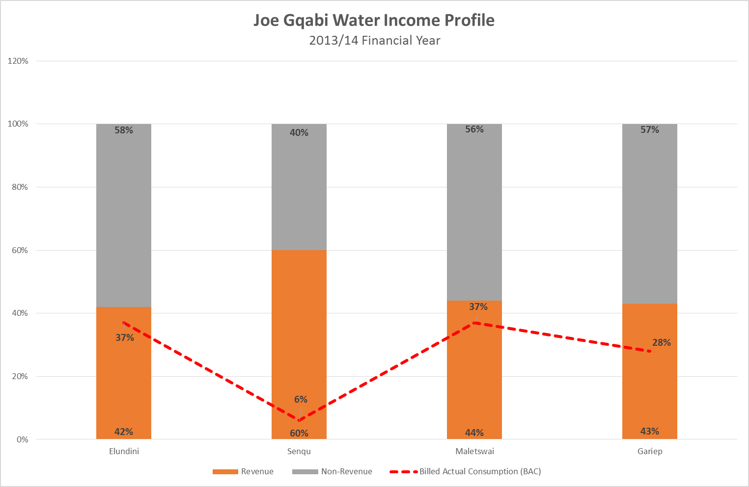

The above results are initial and further work is expected, where-after strategies and actions must be developed to turn the situation around.

## Demand-side Management

Local authorities have accepted household water demand of above 1 000ℓ/hh/day for design purposes. This level of water demand needs to be reviewed to ensure sustainability of water resource management. It may be appropriate to reduce this anchor to levels of around 850ℓ/hh/day. The graphics below demonstrates the effect of reducing the household water demand on capital investment at the Ugie WTW.

Figure ‑: Ugie WTW Capacity vs Demand and Reserve Margin of 15%

The graphic below has been compiled with a household water demand of 1 000ℓ/hh/d. As can be seen, an additional 2 Mℓ/day will have to be added to the existing capacity, as early as 2026/27 as opposed to only 1Mℓ/d in 2041/42 for the case of a household demand of 850ℓ/d.

Figure ‑: Ugie WTW Capacity vs Demand and Reserve Margin of 15%

## Supply-side Management

It may be necessary for both urban and rural households to consider the use of on-site water storage to take advantage of rainwater collection, even if it is for selected gardening and/or some household use. This must be evaluated as part of the WC/WDM strategy of the JGDM

# Environmental Considerations

# Priority Intervention Action Plan

Planning is key to the provision of services, especially with a substantial backlog that must be eradicated. The compilation of master plans and the assessment of the resource base must be dealt with urgently. The JGDM has already compiled the IIP, which must be linked to the full backlog and the other capital requirements (refurbishments). The municipality has also looked at “low hanging fruit” approached of intermediate supply options from springs and boreholes in some rural communities while longer term options are under investigation.

Targets for the eradication of backlogs have moved from the initial target year of 2001 to 2010, then 2014 and at present a target date has not been achieved. The Millennium Development Goal targets have been achieved, but South Africa has set itself the ambitious targets of universal coverage for water and sanitation as soon as possible. While national targets are pending, the JGDM can, with the aid of the preliminary approach of **Section 12.5**, formulate achievable targets for itself to tackle the backlogs and influence the national dialogue on the matter.

# Water Service Institutional Profile

The institutional form of the water and sanitation services is important. This also goes for the other allied services, such as

* Roads to access water and sanitation infrastructure
* Electrical supplies to support the operation of the services infrastructure
* Human resources for the operation and management of the services
* Regulatory services to ensure that quality is attained and the infrastructure effectively addresses human development.

## The Macro/External Environment

The figure below illustrates some of the relationships that govern and influence the provision of water services. The key players comprise the National Sphere, with DWS and National Treasury, the Provincial Sphere, comprising COGTA and the Local Sphere, comprising Local Government (DM and LM), Water Boards and other Water User Entities and Communities

Figure ‑: South Africa's Water Management Structure and Relationships

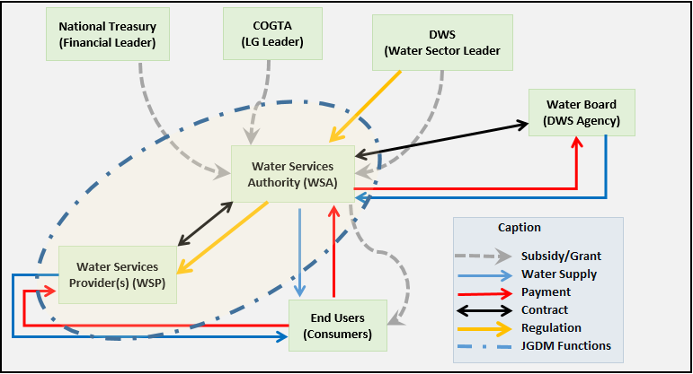

The WSA is by definition a municipality, comprising another layer of stakeholders (communities, unions, employees, business sector(s), service providers etc.). The macro environment of the WSA is depicted by the illustration above, while its micro-environment includes the stakeholders in the preceding sentence. The aspects encircled cover the WSA and WSP functions, which may be undertaken by the local authority or the WSP function may be undertaken by an external entity (organ of state or a private entity). Modifications in the relationship between the WSA and the WSP invoke the provisions of section 78 of the municipal Systems Act. Insofar as the JGDM is concerned, such a process has been undertaken and the WSP function is now being re-incorporated into the DM structure, whereas it as previously contracted out to the LM’s in the DM jurisdiction. The WSA function forms a link between the macro environment and the micro-environment.

## The Micro/Internal Environment

The JGDM has control of or can manage its micro-environment. This environment consists of its structure and resources (inclusive of staff) and systems to manage the provision of services. The WSP function is central to the actual provision of water and sanitation services.

The capacitation of the WSP function is therefore of critical importance, as the provisioning function is at the core of the service. The provision of infrastructure is undertaken in the Technical Services Directorate, by the PMU and the PIU sections. The Operations Function has now also been incorporated into the Technical Services Directorate. The following functions are required to undertake and support the provision of water services

* Administration
* Planning
* Operations
* Human Resources
* Finance
* Legal Support
* Project Management

The JGDM has recently restructured the provision of services by moving the provision from the local Municipalities to the District Municipality. This initiative is in the process of being fine-tuned.

Also, the regulatory function (WSA) sits with the Community Services Directorate, with the operational and capital works functions residing in the Technical Services Directorate. This arrangement is aimed at improving the regulatory capacity and for good governance. Financial aspects are dealt with by the Finance Directorate. ***The compilation of a WSA Business Plan can assist with the allocation of functions, and the necessity to ring-fence the services administratively and financially to ensure good management and sustainability***.

The compilation of or completion of the WSP capacitation Business Plan will set out the tactics and actions to ensure that services are provided sustainably.

The overall guidance for the provisioning function is undertaken by the WSA within the JGDM. The WSA provides strategic oversight and links up with the various components of the macro or external environment. ***It is also proposed that a capacitation business plan be compiled for the WSA function within the Community Services Directorate.***

## Current Structure

The current structure comprises the undertaken of all water and sanitation related functions internally within the JGDM. The functions listed under the micro environment are all undertaken in existing internal departments. These are not ring-fenced within any of the water services related. The internal JGDM departments provide support to the WSP and WSA functions within the integrated municipal management system and no operational ring-fencing exists. The structure is devised to minimise costs, as separate line items for each function within the operating units for water and sanitation may duplicate costs. The current structure allows for costs savings. Ring-fencing may however still be achieved administratively

# Conclusions

The JGDM has recently completed a restructuring exercise where the provision of water and sanitation services to households was migrated from a previous arrangement where it was undertaken by the various LM to the DM now taking the operational responsibilities. The DM therefore requires capacitation to allow it to discharge this accountability competently. The following is required to undertake operational responsibilities in the water and sanitation utility environment:

Figure ‑: Effective Utility Management Factors

[13]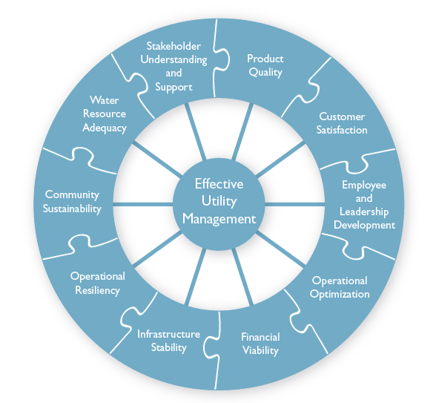

The above schematic is an aspirational goal for water services utilities. It illustrates however that Water and Sanitation Utilities in the world are all challenged by similar challenges, albeit at different levels of endowments and success. A starting point for the JGDM will be to undertake/complete the following documents urgently:

* WSA Capacitation Business Plan
* WSP Operations and Maintenance Business Plan

A key objective must be to improve the financial resources available for the operations and maintenance of the services. Capital is generally a key focus and allocations are more specifically circumscribed. Depending on the strategies and tactics followed by the JGDM, the services backlog can be tackled and eradicated in a maximum of 13 years. This period can be considerably shortened, depending on what implementation tactics are adopted.

It is however the operational capabilities that will have the more lasting impact. Good operational capability can maximise the value extracted from most infrastructure endowments. Good operational capabilities can also act as a bulwark against other challenges. The structure and income of the operational function must be investigated in detail and an approach formulated to capacitate the function with long term sustainability.

## Employee and Leadership Development

South Africa has suffered a general deterioration in overall skills levels and the water and sanitation industry has not been spared this challenge. Infrastructure has expanded rapidly in the last 22 years and the skills levels have not kept pace.

## Operational Optimisation

More is required of water services infrastructure as it is expected to provide to higher numbers of households than often designed. It is often not necessary to build more, but to find ways to optimise existing assets and extract more value out of assets by utilising newer technologies and operational approaches. This is the challenge of achieving more with the same.

## Financial Viability

The income base of local government is strained. Households are generally poor and the unemployment and poverty levels in rural areas have become more severe. The structure of the South African economy has not adapted fast enough or appropriately to address these emerging issues. Water provision at a uniform national level requires adequate operational financial resources that are often not immediately addressable in rural municipalities. It is therefore imperative for the JGDM to improve the financial viability of water services provision and improve the over-reliance on grants as currently the case and to make the services more user-charge reliant.

## Infrastructure Stability

A solid and workable infrastructure base is the foundation of water services provision. The provision of large scale services is capital intensive. The infrastructure is expensive and requires sophisticated engineering and operation.

## Operational Resiliency

While solid infrastructure is key, operational resiliency is the characteristic requires to make infrastructure as efficient and reliable as possible. This is the combination of skills, resources, systems and institutions. Resilient operations will transcend a lot of deficiencies in capital and infrastructure.

## Community Sustainability

Community sustainability encompasses a number of specific issues. Efficient communal layouts, adequate income levels, a culture of ownership and accountability, cooperation, trust, low poverty, adequate incomes and high employment levels are some of the critical factors of community sustainability.

## Water Resource Adequacy

Water resources are important. These cover surface and underground resources. It also includes innovations such as better utilisation of rainwater. This also incorporates balancing of competing needs and issues of equity between competing needs. Resource conservation has become a central tenet of maintaining a balance between demand and supply in South Africa. Cognisance must also be taken of allowing for environmental/ecological water requirements.

## Stakeholder Understanding and Support

The stakeholders in water services provision are numerous. Thy include the following

* Communities in general
* Business
* Government institutions
* Lobby groups
* Politicians

These are broad categorisations that need to be catered for in detail per schemes/area/project.

## Product Quality

Water services is about product quality and quantity. Product quality makes the highest impact on both consumers and the environment. Households must receive wholesome water that is not deleterious to health. Discharges of wastes into the environment must meet stringent requirements such that it will not degrade the receiving environment or its assimilative capacity and negatively affect human health. There are existing standards that must be met and all systems must be designed and/or operated to meet national standards of quality.

## Customer Satisfaction

Customers, be they domestic or otherwise are at the centre of water services provision. The definition of water services in South Africa have been redefined to take this into account. The needs and aspirations of the customers must receive the full attention of the water services provider. This is not only because they are expected to pay for services, but also because of the value systems embedded in our constitution that value people. It is imperative for WSA and WSP’s to proactively communicate and inform customers and not to wait for them to raise issues. The perceptions of customers therefore need to be seriously considered and managed.

.

1. Schulze et al, South African Atlas of Agrohydrology and Climatology
2. Worldweatheronline
3. Worldweatheronline
4. 2011 figure, un-adjusted for growth
5. ECSECC Data from 2010
6. QLFS, Q2, 2015
7. All Towns Reconciliation Strategies – Individual JGDM Towns
8. All Towns Reconciliation Strategies – Individual JGDM Towns
9. Aurecon appointed
10. Extracted from the Orange River Reconciliation Strategy 2015
11. Aurecon Report, Water Loss Evaluation Report, Financial Year 2013/2014
12. Aurecon Report, Water Loss Evaluation Report, Financial Year 2013/2014
13. Effective Utility Management A Primer for Water and Wastewater Utilities, June 2008